Welcome to the South Puget Sound Community College Student Employment NEOGOV Guide. Students will be able to use this site to navigate different job opportunities on and off campus.

Create an Account

Follow these steps to create account:
- Go to the South Puget Sound Community College Employment webpage, https://www.governmentjobs.com/careers/spscc/promotionaljobs and press “Sign In” at the top right corner of the page.
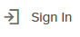

- Click “Create one” located at the bottom of the Sign In Box
Important information:
- Use South Puget Sound Community College student email address
  - Username must be unique and cannot contain spaces or special characters
  - Your password must be at least eight characters in length contain both upper and lower-case letters, numbers and symbols. Previously used passwords or commonly used words/phrases are not permitted
  - Keep a record of your username and password
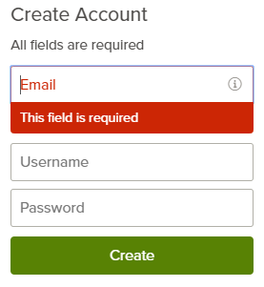

- Once you have entered an acceptable email, username, and password click “Create”

Apply for a Job

Follow these steps to apply for a job:

- Click on the “Apply” button from job details:
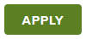

- You can accelerate completing basic profile information by importing a resume.
- This option does not upload your resume to your application
- Review information that is imported to ensure all required fields are complete
- If any information is removed from profile user must click to refresh the page

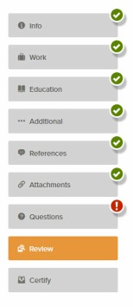
- Next you complete a series of steps. The specific steps that you must complete are determined by job posting.
- Your progress is shown on the left-hand side of the screen
- As you work on your application, refer to the progress bar to see the number of items for each entry, and errors. A green check mark indicates all required information is complete. A red exclamation means you are missing required information.

- For each step, the buttons on the bottom allow you to save or discard your work on this entry.
- Although your typing is periodically saved, it is good practice to click on “Save” after each entry.
- The “Cancel” button discards any changes you have made since the last save.
- For some entries, the “Remove” option is present. It deletes the current entry (such as a previous job), after a confirmation. Once deleted, the data cannot be recovered. Remember to refresh the screen after removing data to regain full accessibility within site.
- The last time that the entry was saved is also displayed at the top:

- Upload attachments
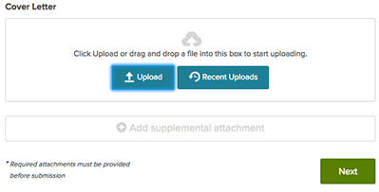
- All student employment positions require a resume and cover letter.
- If you have previously uploaded attachments, you can use the “Recent Uploads” button to access these files.

- Answer any additional questions.

- Once your application is complete, select “Proceed to Certify and Submit”.

- On the Certify & Submit page, click on “Accept and Submit”.
- An application submitted message confirms that you have applied for the job.

Navigating User Options

- When you are signed in, your username appears on the right in the top menu bar:

- The drop down menu under your username lets you quickly access common user options:
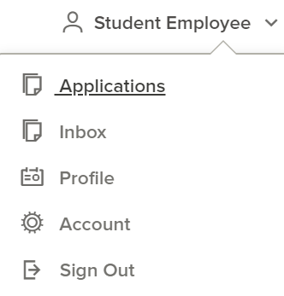
- Applications: Review your job applications and check status of submitted applications. Review and complete incomplete applications.
- Inbox: Read and respond to communication regarding applications.
- Profile: Update basic information that you use to apply for jobs. Changes that you make do not update previously submitted applications but are saved for future applications.
- Account: Edit your contact information or change your password. If you change your contact information, this information is updated with employers with which you have applied.
- Sign Out: Logs user out of NEOGOV website.

Application Status and Interview Selection

- Once an application is successfully submitted you can view the status by clicking “Applications” in the user options section.

- For Submitted Applications click on “Submitted” 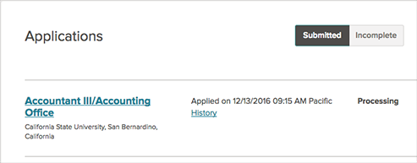
- Click on the job title for more information and to see the details of your submitted application.

- You can also click on the down arrow to see more information. This can include a summary of the steps in the hiring process including if selected for an interview.
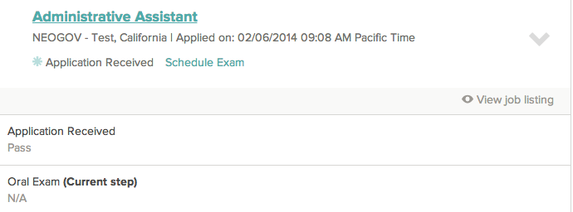

- Remember to check, both, your SPSCC email and your NEOGOV inbox for any further correspondence regarding the position.

