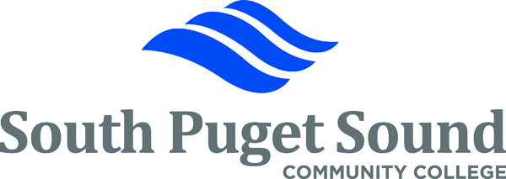
Washington State Executive Ethics Board Training
Certification of Completion

I _________________________, certify that I have completed and understand the Washington State Executive Ethics training which included the following training modules:

• 12 Sessions
• 12 Scenario Answers
• Online Ethics Quiz

___________________________
Employee Signature

____________________________
Date Completed

Thank you for completing the Washington State Executive Ethics Board Training. Please send the signed original Certification Form to Human Resources.

This Certification of Completion will be placed in your personnel file.

If you have questions, please contact Human Resources at x5500

