NAVIGATE360 GUIDE
Appointment Campaigns in Navigate360
STAFF GUIDE

Purpose
This guide shows you what Appointment Campaigns are, how to open them, how to track them, the metrics they show, and the permissions you need. An Appointment Campaign lets you invite a specific group of students to schedule an appointment with you, such as advising or another service.
What Appointment Campaigns Are
An Appointment Campaign lets you reach out to a group of students and ask them to schedule an appointment. You use it when you spot a group who could use extra support and want to invite them to meet with you. You build the group with Advanced Search, then send an invitation with a scheduling link.
Before you start: An Appointment Campaign needs a few things in place. You must have calendar sync and availability set up, the permission to create appointment campaigns, and access to Advanced Search to build your student list. If you do not have the permission to create appointment campaigns, work with your care unit lead, who submits an IT ticket so the Navigate360 team can complete the work.

Note: This guide is an overview of Appointment Campaigns and how to read their results. The full step by step for building and launching a campaign is a separate topic.

Opening Appointment Campaigns
You can open Appointment Campaigns two ways:
- From the Quick Links section on your Staff Home page.
- From the Campaigns page. Click the Campaigns icon on the blue navigation bar, then select Appointment Campaigns.
To start a new campaign, click Add New.
Tracking Your Campaigns
After you send a campaign, you track it from the Appointment Campaigns page. Each active campaign shows six at a glance stats:
- Status. Whether the campaign is Draft, Active, or Expired.
- Recipients. The number of students who got the invitation.
- Goal Achieved. The number and percent who met the Campaign Goal.
- Appointments Scheduled. The percent of invitees who scheduled an appointment.
- Appointments Attended. The share of invitees who attended, based on attendance records or kiosk check ins.
- Summaries Created. Of the scheduled appointments, the percent with an Appointment Summary filed.
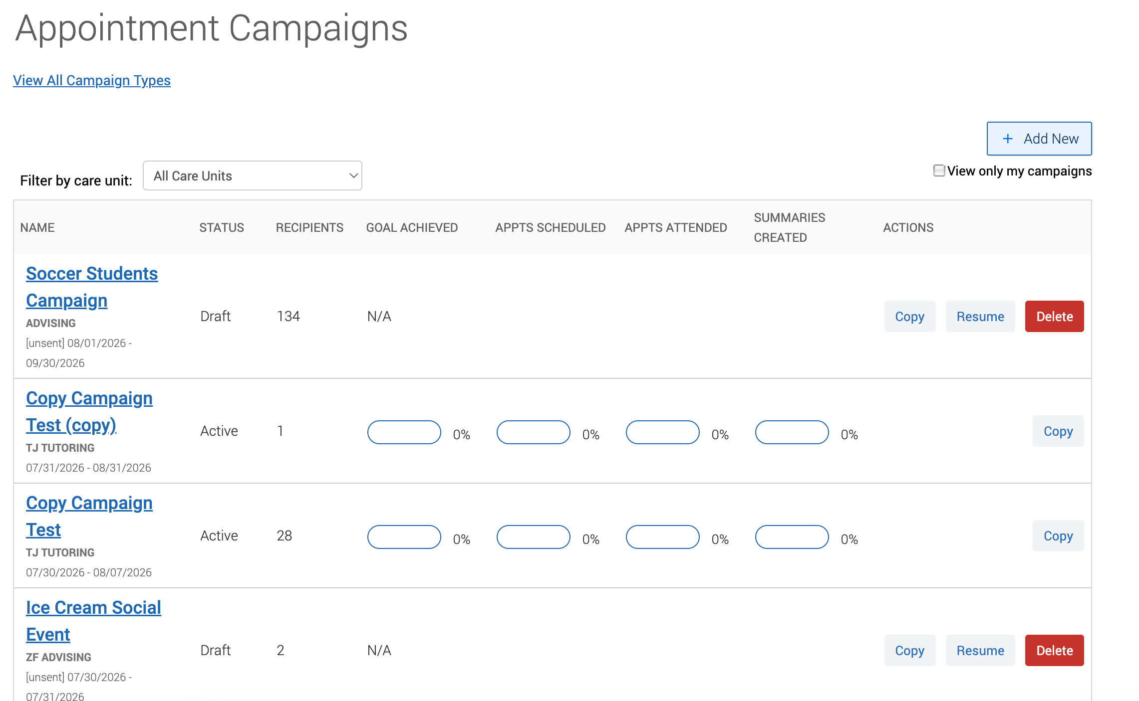
Note: Unique attendance means the attended box was checked in the Appointment Summary. A group appointment counts as one attendance.

The Campaign Report
Click a campaign name to open the full report. The Options sidebar lets you edit, copy, or delete the campaign, or export the student list. The Campaign Information box shows the campaign settings, such as care unit, service, location, and scheduling window.
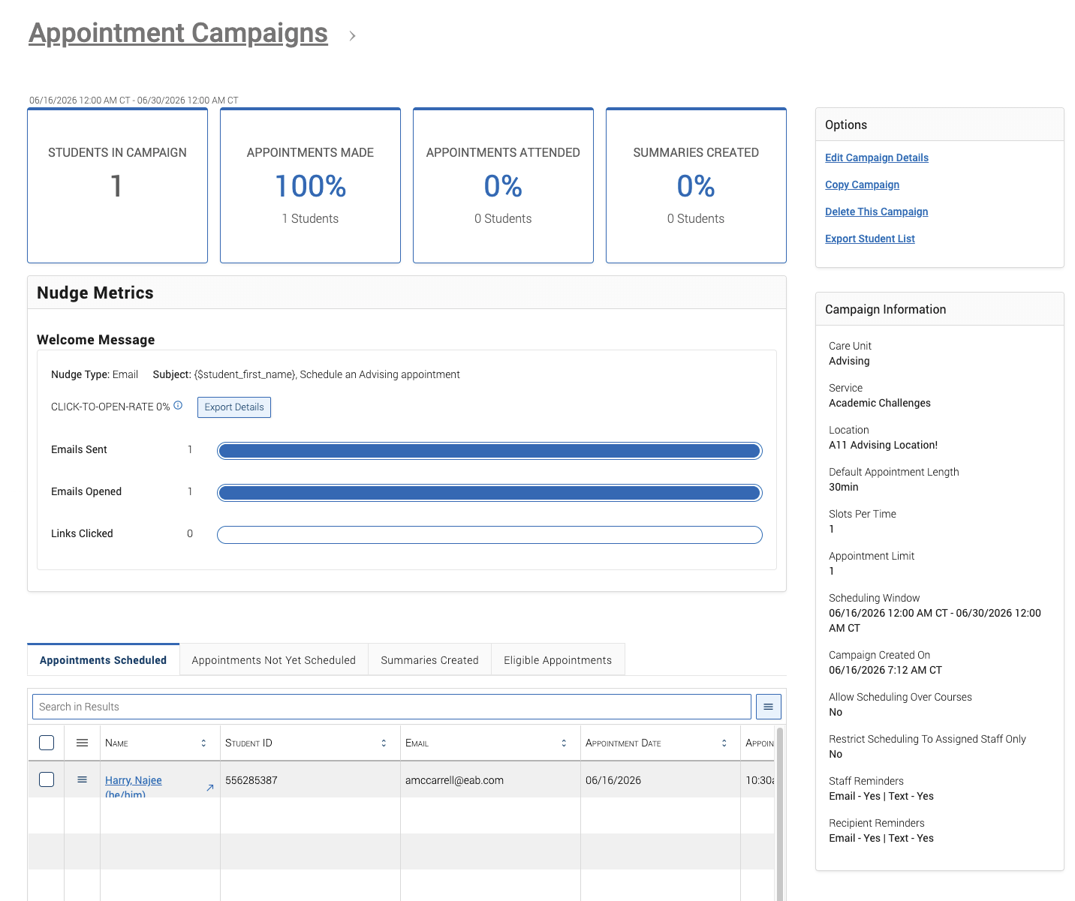
The report shows these metrics:
- Students in Campaign. The number of students who were sent the campaign message.
- Appointments Made. Number and percent who have made an appointment.
- Appointments Attended. Number and percent who have attended an appointment.
- Summaries Created. Number and percent with an Appointment Summary filed.
- Click to Open Rate. Compares unique clicks to unique opens.
- Emails or SMS Sent. The number of messages sent. This can differ from the size of your original list.
- Emails or SMS Opened. The number of messages that were opened.
- Links Clicked. The number of times the link in the message was clicked.
You can export details for any message or nudge with the Export Details button.
Important: Nudge metrics and Click to Open Rate details are not on by default. To turn them on, work with your care unit lead, who submits an IT ticket so the Navigate360 team can complete the work.

The Report Tabs
The report has tabs for working with students at each stage. You normally see four, with a fifth appearing when a campaign asks for more than one appointment:
- Appointments Scheduled. Students who made an appointment. Click a name to open their profile, or use the Actions menu to send a message, add a note, or add a tag. You can also view appointment details from the menu next to a student.
- Some Appointments Scheduled. Appears only when a campaign asks for more than one appointment. It shows how many appointments a student still has left. Students here also show on the Appointments Scheduled tab.
- Appointments Not Yet Scheduled. Students who have not scheduled yet. You can message, note, or tag them, resend the campaign email, or copy a scheduling link to send.
- Summaries Created. The Appointment Summary Reports filed from the campaign. You can view or delete a report here.
- Eligible Appointments. Lets you count appointments that were booked without the campaign link. Open the tab, select the appointment, and choose Associate Appointments from the Actions menu.
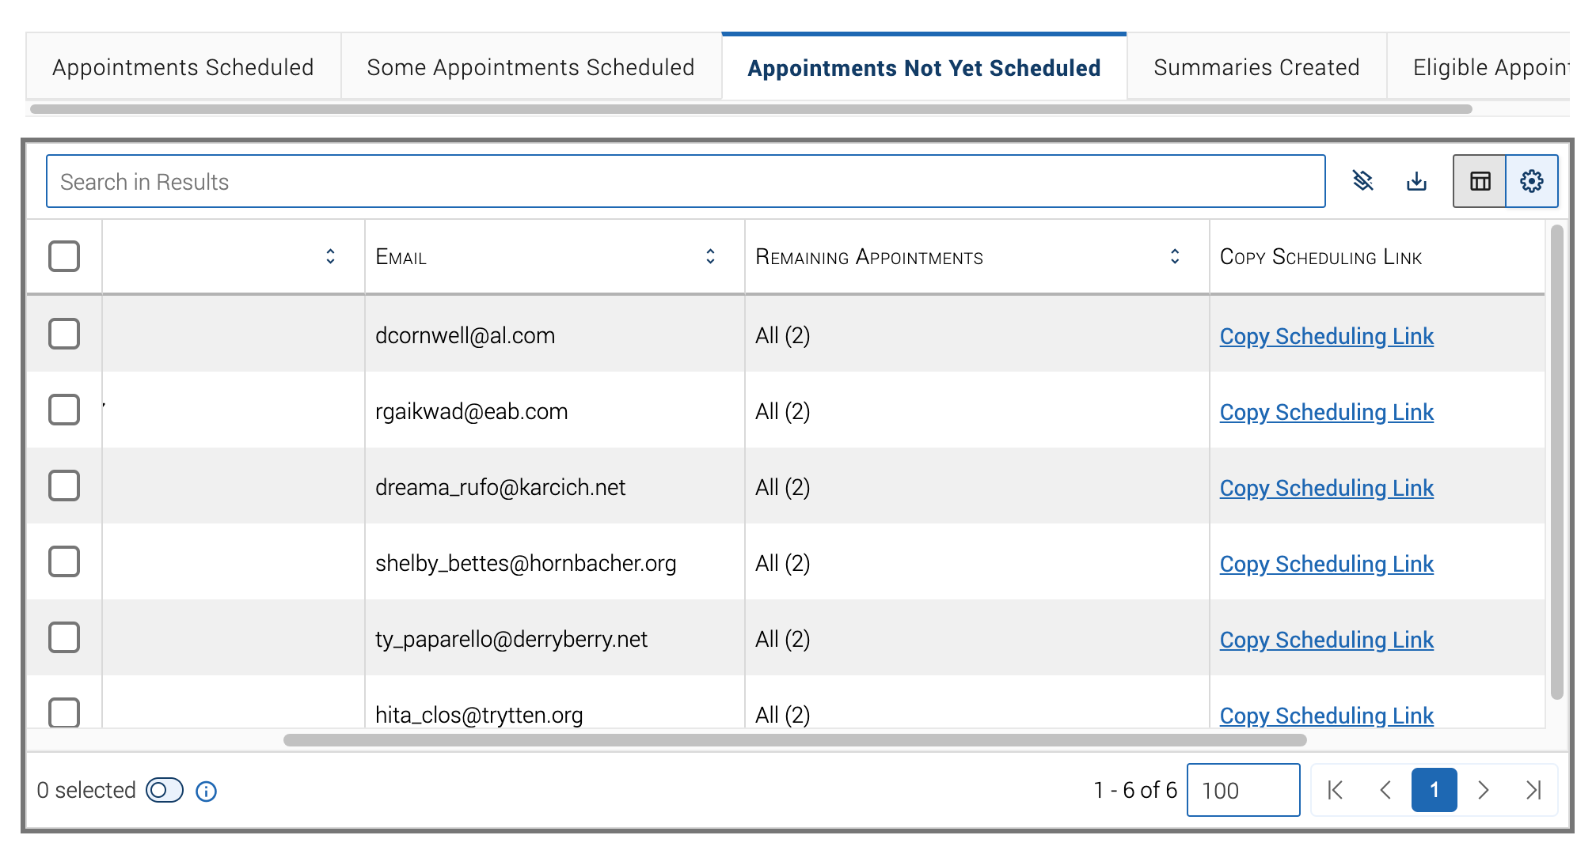
Important: An appointment is only eligible if it has the exact same Location and Service as the campaign, the student is on the campaign list, and the appointment organizer is included as staff on the campaign.

