NAVIGATE360 GUIDE
Creating Availabilities for Yourself in Navigate360
STAFF GUIDE

Purpose
This guide shows you how to set up your availability in Navigate360 so students can schedule appointments with you or use your drop in times. It covers syncing your Navigate360 calendar with Outlook so your appointments appear in one place and you prevents double booking. You must have at least one availability set up before students can book time with you.
Syncing Navigate360 with Your Outlook Calendar
Before setting up availability in Navigate360, plan to sync your Navigate360 calendar with Outlook. This helps prevent scheduling conflicts and ensures appointments appear on your primary SPSCC calendar.
Syncing allows scheduled appointments to appear on your Outlook calendar and helps keep your availability accurate.
Setting Up Calendar Sync
- Open My Calendar in Navigate360.
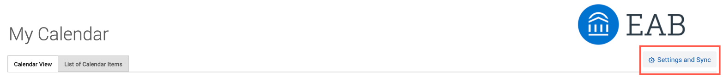
- Select the Settings and Sync button.
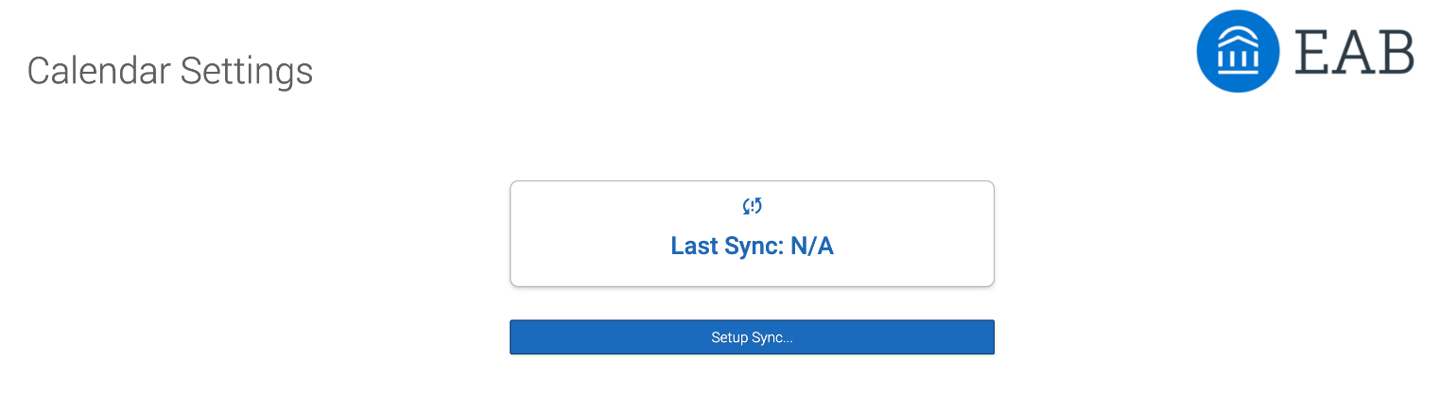
- If you have not yet set up a calendar sync, you will see an option to begin setup.
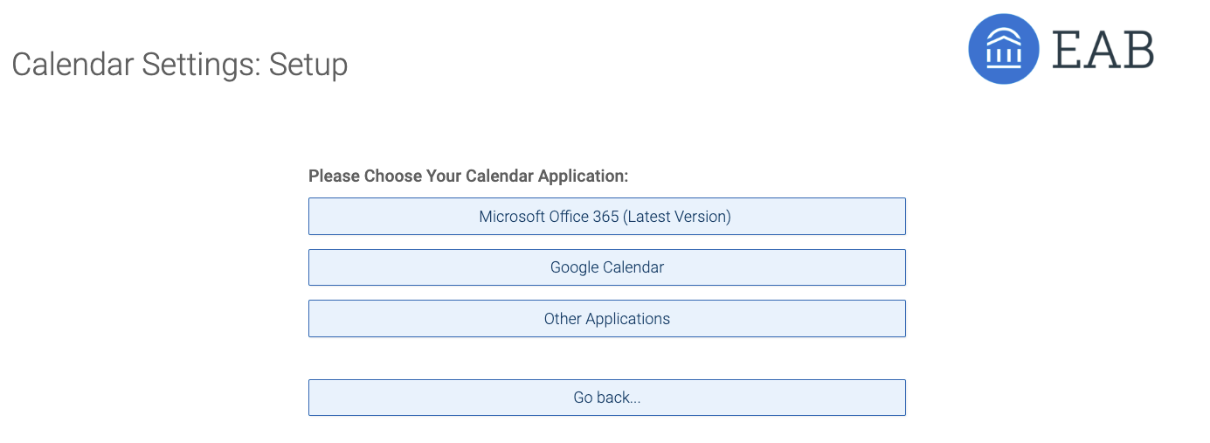
- Click Setup Sync. The Calendar Settings: Setup page opens.
- Choose Outlook Service Accounts, the sync is automatically set up.
- Once the sync is completed, you return to the main Calendar Settings page with information about their sync on display.
Setting Up Availability in Navigate360
To schedule appointments with students in Navigate360 and allow students to schedule appointments with you, you must have at least one availability set up.
- Go to Staff Home > My Availability. You will see a table of any existing availabilities and your Personal Availability Link.
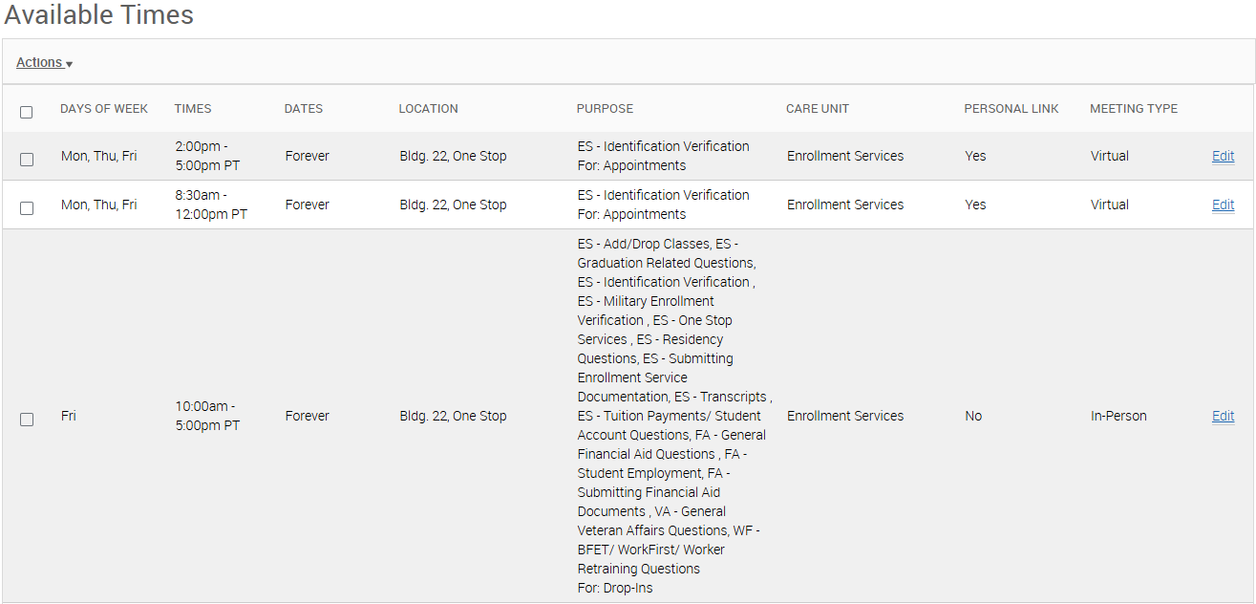
- Open the Actions menu and select Add Time.
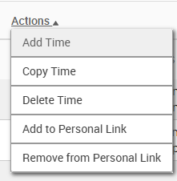
- The Add Availability dialog opens.
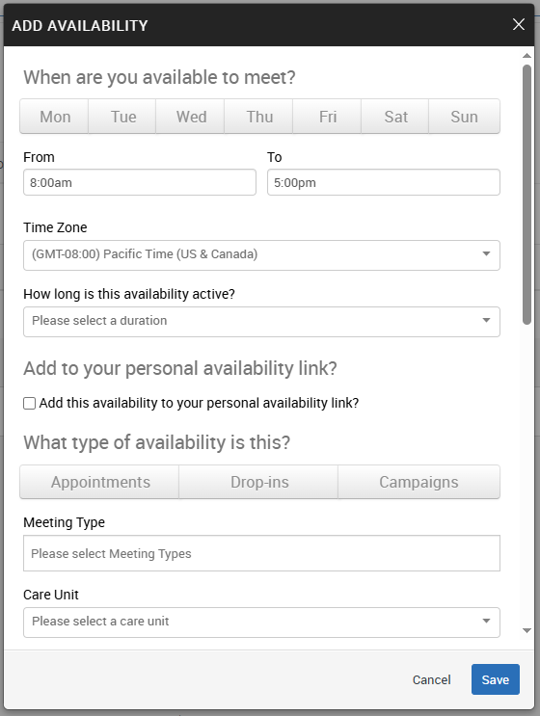
- Choose the days of the week for this availability.
- Select the start and end time in the From and To fields.
Remember, you can make multiple appointment blocks for a day. You may consider creating blocks around lunch, breaks, reoccurring meetings not on your calendar, or class times.

- Set your Time Zone, if needed.
- Set how long this availability should remain active using the How Long Is This Availability Active? field.
If this is a reoccurring availability you may want to choose forever. If your availability changes you will want to set specific dates.

- If you want this availability included in your Personal Availability Link, select Add This Availability to Your Personal Availability Link? You can share this link by email, text, or on a website. Students will be taken to a scheduling workflow with your availabilities pre filled, including in the Navigate360 Student mobile app.
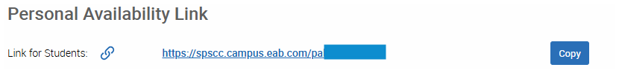
- Select your Availability Types. You may choose more than one, such as Drop In and Appointments.
- Select your Meeting Types. You may choose more than one, such as In Person, Phone, or Virtual.
- Select a Care Unit. This determines which locations and services are available.
- Select a Location.
- Select one or more Services. You must choose at least one service.
Important: A Care Unit, Location, and at least one Service are required for every availability.

- If any selected service is tied to a course, a Course field will appear. Select the course or courses you are available for.
- Enter a phone number or meeting link, such as Zoom or Teams, in the URL / Phone Number field. This information is saved when the appointment is created and only applies to that specific appointment. Changes will not update existing appointments or previously sent notifications. Students will see a clickable phone number or meeting link on their Appointment Confirmation page.
- Optional. Enter Special Instructions for this availability. Use this field to include meeting policies, expectations, or items students should be prepared to bring or complete. This information is visible to students when they schedule an appointment.
- Set the Max Number of Students per Appointment. If no maximum is selected, the default is one student.
- Click Save to create the availability.
Note: Repeat this process any time you want to add additional availabilities. You may create as many availabilities as needed.

Managing Existing Availabilities
When you create availabilities, you can usually edit, copy, or delete them.
To edit an existing availability, click the Edit link next to the entry you want to change. Editing an availability is very similar to adding an availability, so refer to the instructions above for details.
Please note: Editing or deleting an existing availability does not change any appointments that are already scheduled. Changes you make to your availability show in the Student Scheduler right away.

To copy an existing availability, select the time you want to copy, open the Actions menu, and click Copy Time. The availability is copied and a Modify Availability dialog opens, so you can make edits or save your new availability.
To delete an availability, select the time, open the Actions menu, and click Delete Time.
Planning Your Availability
You may create multiple availability blocks within the same day. This allows you to intentionally plan your schedule, including breaks between appointments, coverage for different services, or separate time blocks for specific student needs.
Setting up multiple availability blocks can help you:
- Build in scheduled breaks without manually blocking time
- Separate drop in availability from scheduled appointments
- Offer different meeting types or services at different times of day
- Protect focused work time between student meetings
For example, you might create a morning appointment block, a mid day break with no availability, and an afternoon appointment block. Each availability block can have its own services, meeting types, and instructions.
We recommend planning availability blocks intentionally to support sustainable scheduling and avoid back to back appointments throughout the day.

