NAVIGATE360 GUIDE
Getting Help in Navigate360
STUDENT GUIDE

Purpose
Have a question or run into a problem while using Navigate360? Help is built right into the app. This guide shows you where to find it and who to reach out to.
Open the Get Help Menu
Look for the question mark icon near the top right of your screen. Click it, and a Get Help panel opens on the right side.
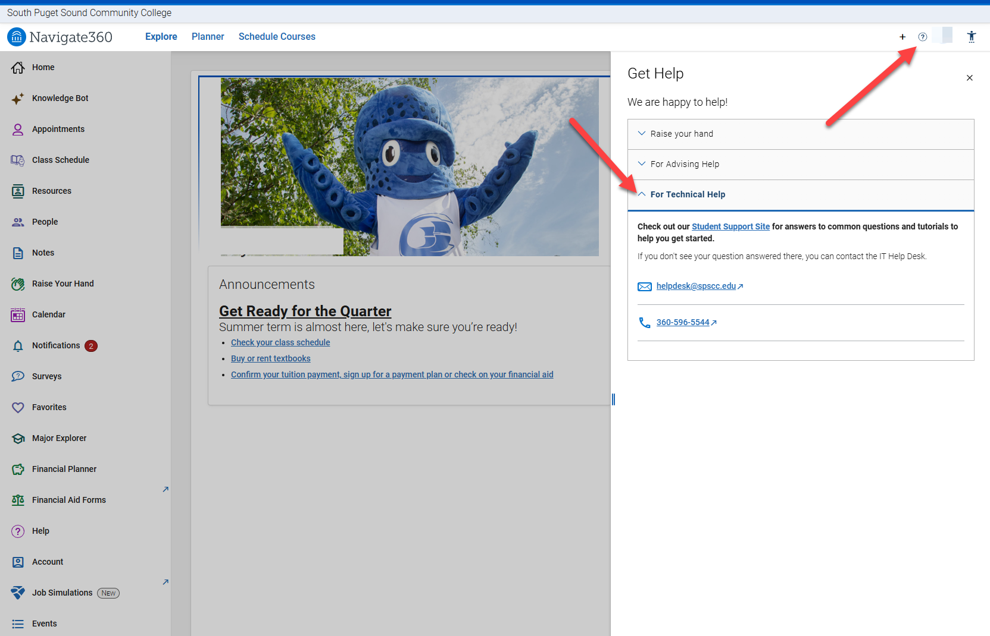
Choose the Kind of Help You Need
The Get Help panel gives you a few choices. Pick the one that fits your question:
- Raise Your Hand lets you ask for help while you are in the app.
- For Advising Help is for questions about advising, like planning your classes.
- For Technical Help is for when something in Navigate360 is not working the way it should.
For Technical Help
When you choose For Technical Help, you will see two things:
First, a link to the Student Support Site, which has answers to common questions and tutorials to help you get started. Check here first, since it may have exactly what you need.
If your question is not answered there, you can contact the IT Help Desk:
- Email: helpdesk@spscc.edu
- Phone: 360-596-5544

Tip: The Student Support Site is usually the fastest way to get answers to common questions, so it is a good first stop before you reach out to anyone.
If this, then this
- If your question is about advising or planning your classes: choose For Advising Help instead of For Technical Help.
- If Navigate360 is not loading or something looks broken: choose For Technical Help, check the Student Support Site, and contact the IT Help Desk if you still need help.

Need to reach the IT Help Desk? helpdesk@spscc.edu • 360-596-5544

