NAVIGATE360 GUIDE
Journeys
STAFF GUIDE

Feature Overview
The Journeys feature in Navigate360 helps students understand and complete essential steps towards their goals. Designed to extend beyond mere course planning, these Journeys empower students to focus on proactive, forward-thinking milestones crucial to their college experience. Some examples of Journeys an institution might configure include New Student Onboarding, First-Year Student Orientation, Affording College, Getting a Job, Graduate School Planning, Preparing for Graduation, and Mental Health & Wellness.
Students can access Journeys from the main menu on Navigate360 desktop or mobile.
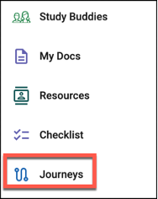
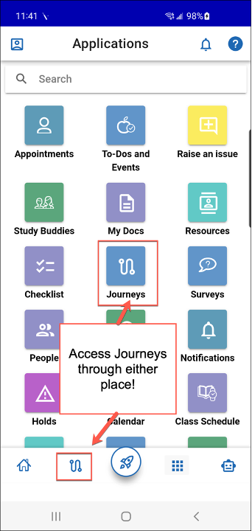
The main Journeys page for students displays any current Journeys the students has had assigned to them by staff or the system as well as any Journeys they added themselves. Beneath that is a section for completed Journeys.
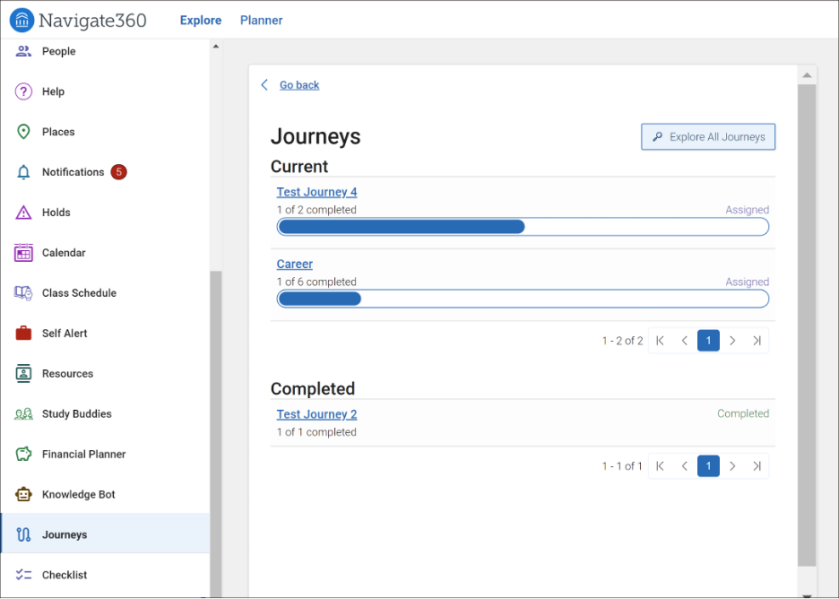
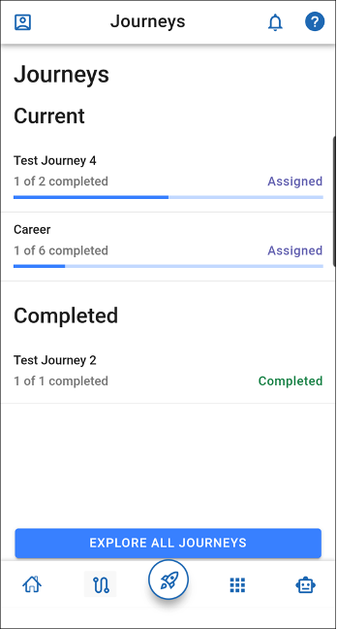
If a student wants to add a Journey, they can explore Journeys your school has created and published using the Explore All Journeys option.
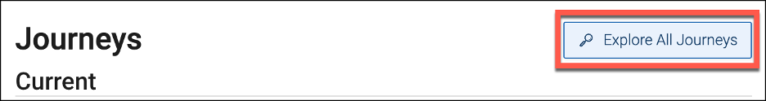
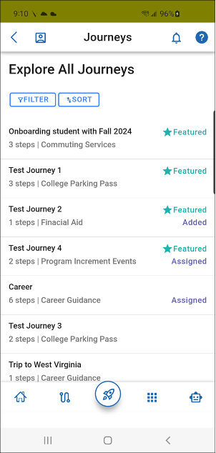

The Explore All Journeys page shows all published Journeys your school has. It will not include any staff-only Journeys. Students can filter based on the Journey Name or Topic.
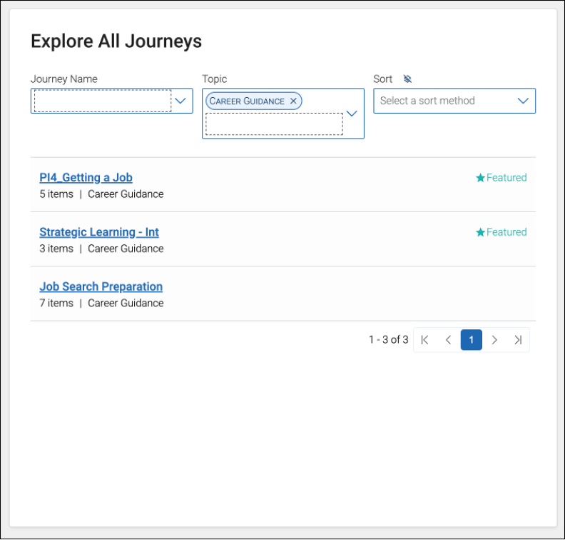
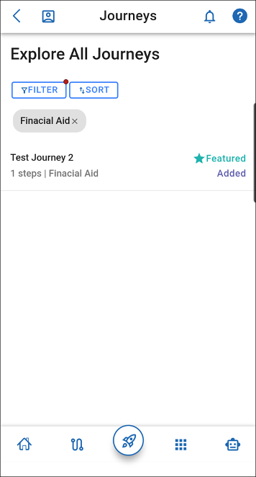
Students can select a Journey from the list, which opens the Journey, and displays a description of the Journey, the steps that comprise the Journey, and any specific step due dates. The student can then add the Journey from this page.
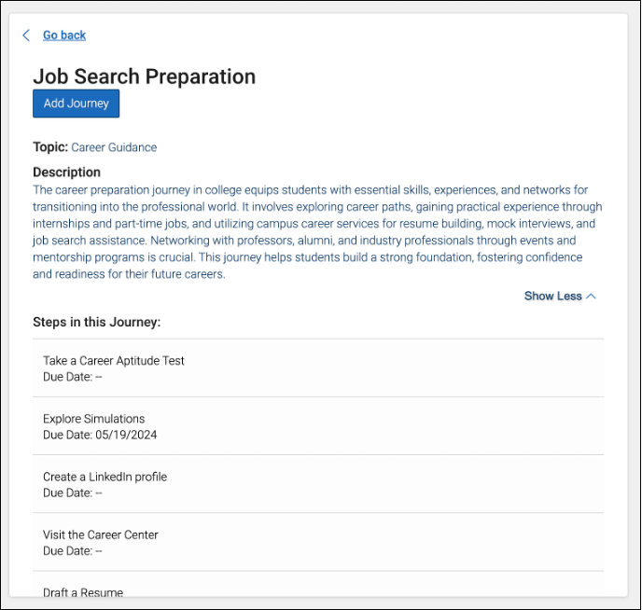
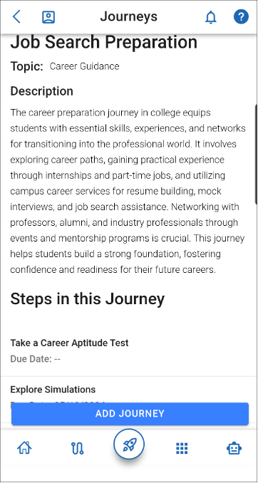
When a student adds a Journey, the steps in the Journey are added to the student’s Checklist. Additionally, the Journey is added to the list of Current Journeys on the main page with a progress bar.
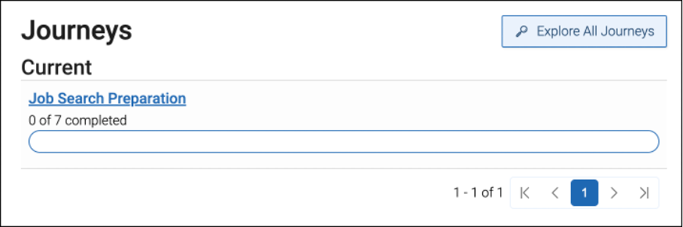
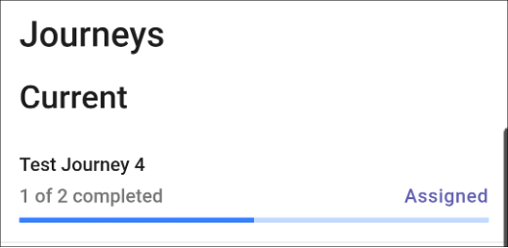

Once students add a Journey, they can also open a Journey from the main page and each step displays with the ability to open the step and mark it completed. The content blocks are prioritized, meaning status and completed fields are collapsed, but can be viewed by students by selecting Show More Details. 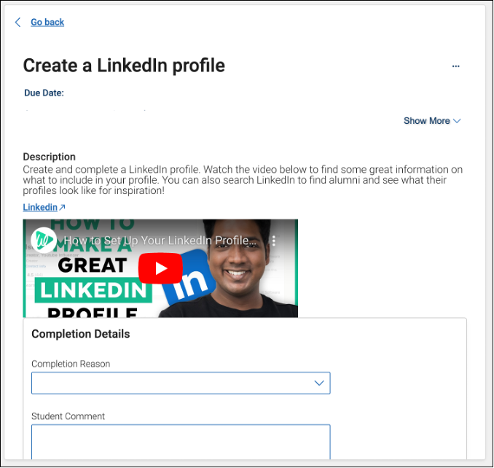
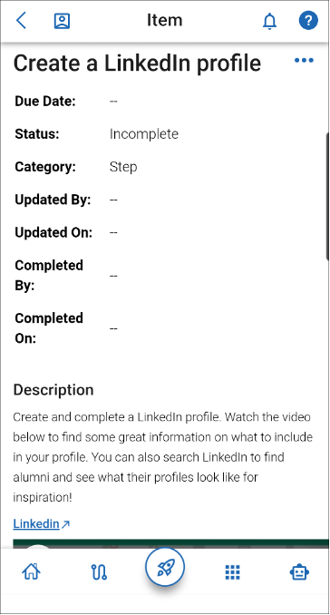

Once a student updates a step, either on the step page or via Checklist, the Journey itself will update, showing the step as completed and displaying progress on the progress bar.
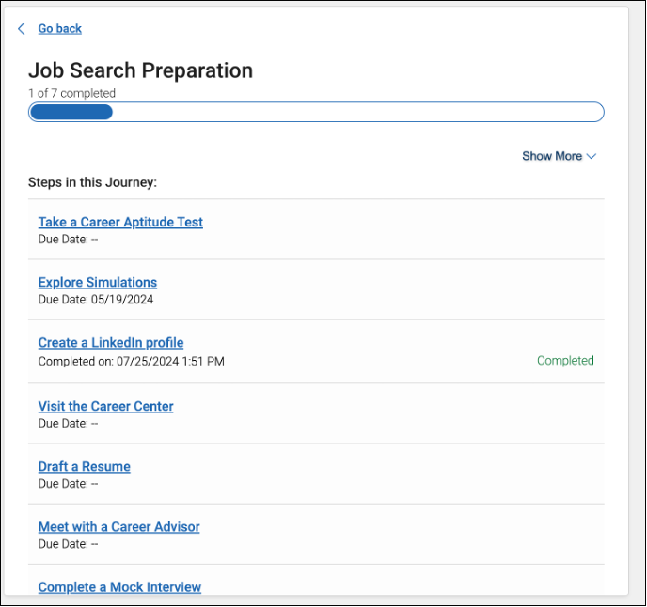
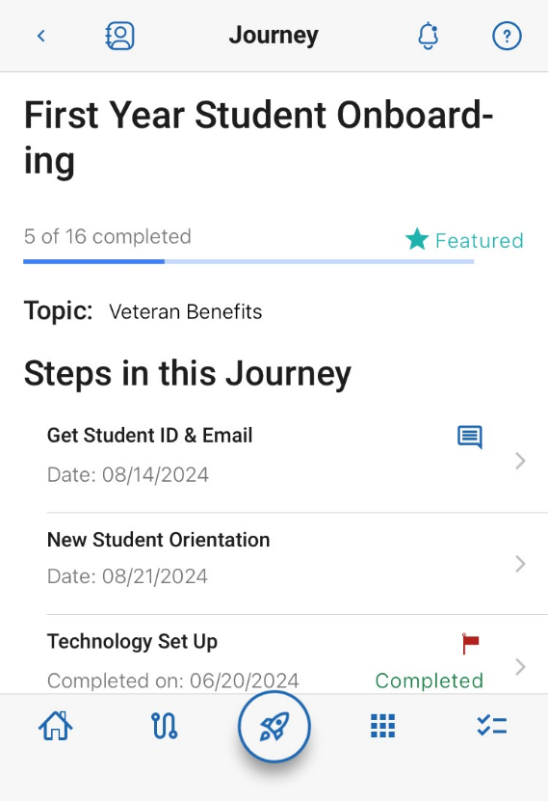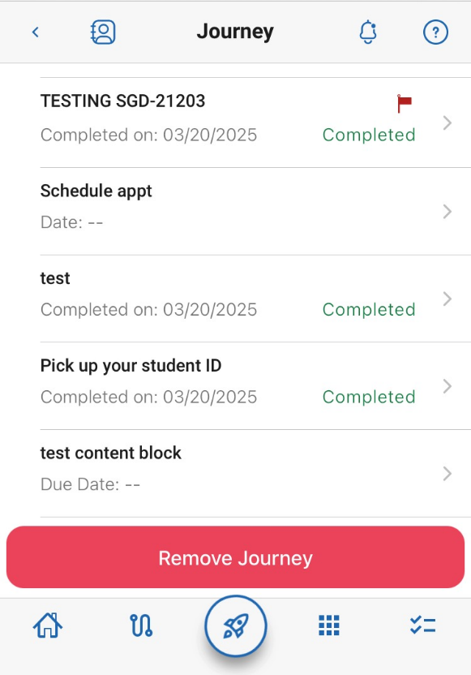

Once students have added or been assigned Journeys, the steps display on the Checklist page of the student app. Staff can also view student Journeys and assign them from the Journeys Report or the Student Profile: Journeys tab.
Students also receive Journey notifications. Times when students will receive notifications (if they have not changed their settings): when they are assigned a Journey, when an advisor comments on a step, or if Steps reminders are configured for a particular Journey step. These appear in the Notifications Center and can also be sent as emails, text messages, or push notifications.

