NAVIGATE360 GUIDE
Managing Alerts in Navigate360
STAFF GUIDE

Purpose
This guide shows you how to issue an Alert on a student in Navigate360, what happens after you issue one, and where you and a student's other staff can go to see it.
What Alerts Are
An Alert draws attention to a student who might be at risk, for reasons like losing financial aid, needing tutoring, or planning to withdraw. Issuing an Alert can create a virtual referral and prompt another department to take action. Access to Alerts depends on your user role permissions. Contact your Application Administrator if you have questions about your access.
Note: Alert Reasons are set up by your institution and sorted by Care Unit, then alphabetically within it. If your role has no Care Unit assignments, you only see Alert Reasons that are not tied to a Care Unit.

Issuing an Alert
You can issue an Alert two ways in Navigate360: ad hoc, or through a Progress Report Campaign. This guide covers ad hoc Alerts, which you can start from a few different places.
From Staff Home or Professor Home. Select Issue an Alert from the Actions pane.
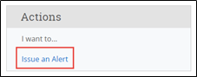
From a list of students. Such as Advanced Search results or your My Assigned Students pane, select a student from the list, then choose Actions and Issue Alert.
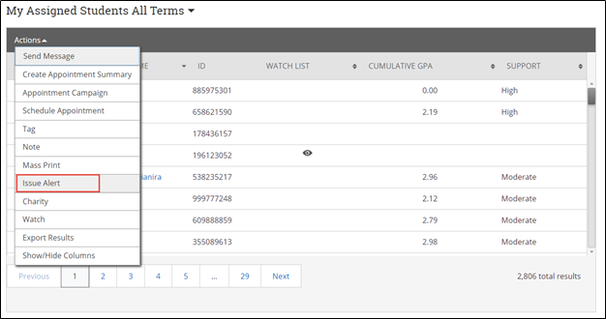
From a student profile. Select Issue an Alert from the Action pane.
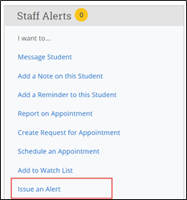
Selecting Issue an Alert opens the Alerts dialog.
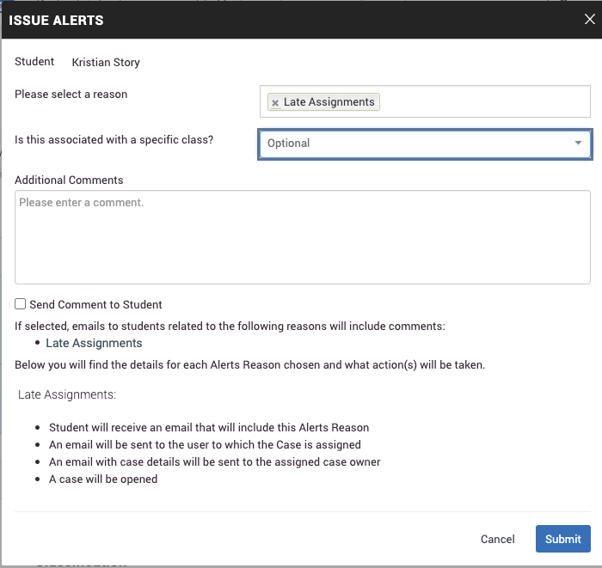
- Alert Reason. Select at least one reason for the Alert. Reasons are set up by your institution and sorted by Care Unit, then alphabetically. Contact your Application Administrator if you have questions about your institution's Alert Reasons.
- Association with a specific course (optional). Select a course from the list if the Alert relates to a course the student is currently enrolled in.
- Additional Comments. Enter your comments here. Staff and faculty with permission can view the Alert and its comments. There is no character limit.
- Send Comment to Student (optional, permission dependent). If you have permission and the Alert Reason you chose allows it, you can send your additional comments directly to the student.
Important: Alert Reasons are tied to Care Units. If your institution uses case management, each Alert Reason you choose may open a separate case for the student.

When you select an Alert Reason, Navigate360 shows you what will happen as a result, right in the dialog. If you choose more than one reason, each one's actions show separately beneath Additional Comments, along with whether it opens a case.
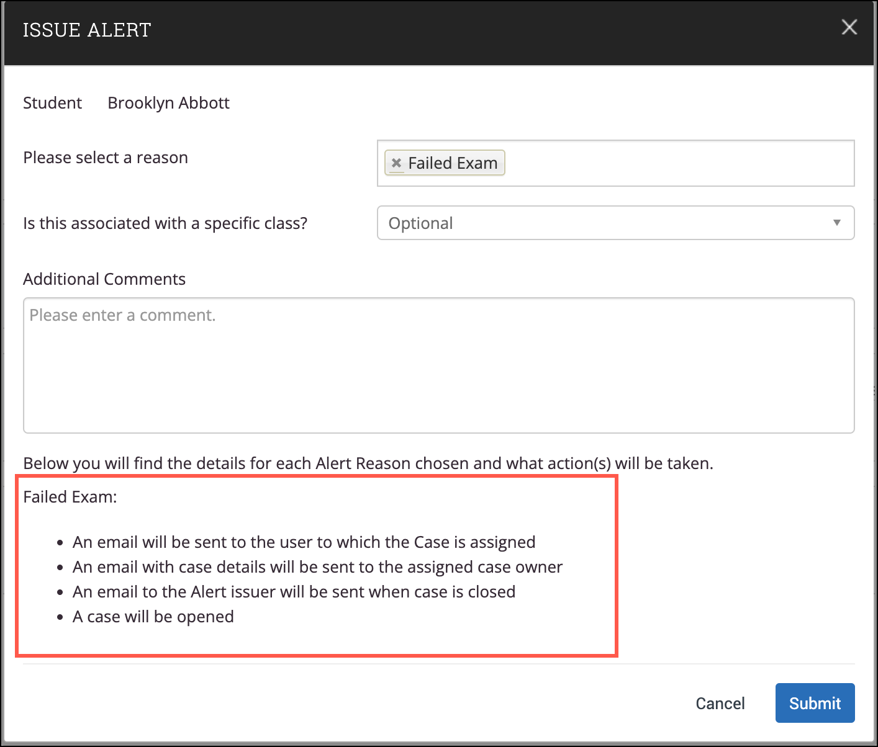
Important: Any information you enter into Navigate360 about a student becomes part of their official student record and may be requested by that student under the Family Educational Rights and Privacy Act, or FERPA.

Issuing Alerts for Multiple Students at Once
Navigate360 lets you issue Alerts for up to 100 students at a time, generating one Alert per student. This is available in Advanced Search, Staff Home (My Students), and other places where you can already issue a single Alert from the Actions menu.
The dialog looks much like the one for a single student, with two differences. At the top you see Issuing Alert for X Students with a link to show the full list, and there is no course selection dropdown. The actions each Alert Reason triggers still show beneath Additional Comments.
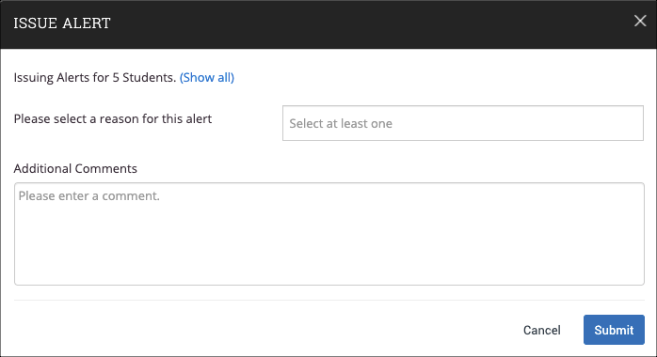
Note: If you select Show All and later want to hide the list again, select Collapse All.

What Happens After You Issue an Alert
Depending on your institution's settings, the assigned advisor, the student, or both may receive an email about the Alert. Your institution decides which notifications go out for each Alert Reason, and it is possible neither email is sent. Contact your Application Administrator if you have questions about what is configured.
Student notification. If the Alert Reason is set up to notify students, the student gets an email from the platform letting them know an Alert was issued. If several Alerts are issued for one student at once, they receive a separate email for each one.
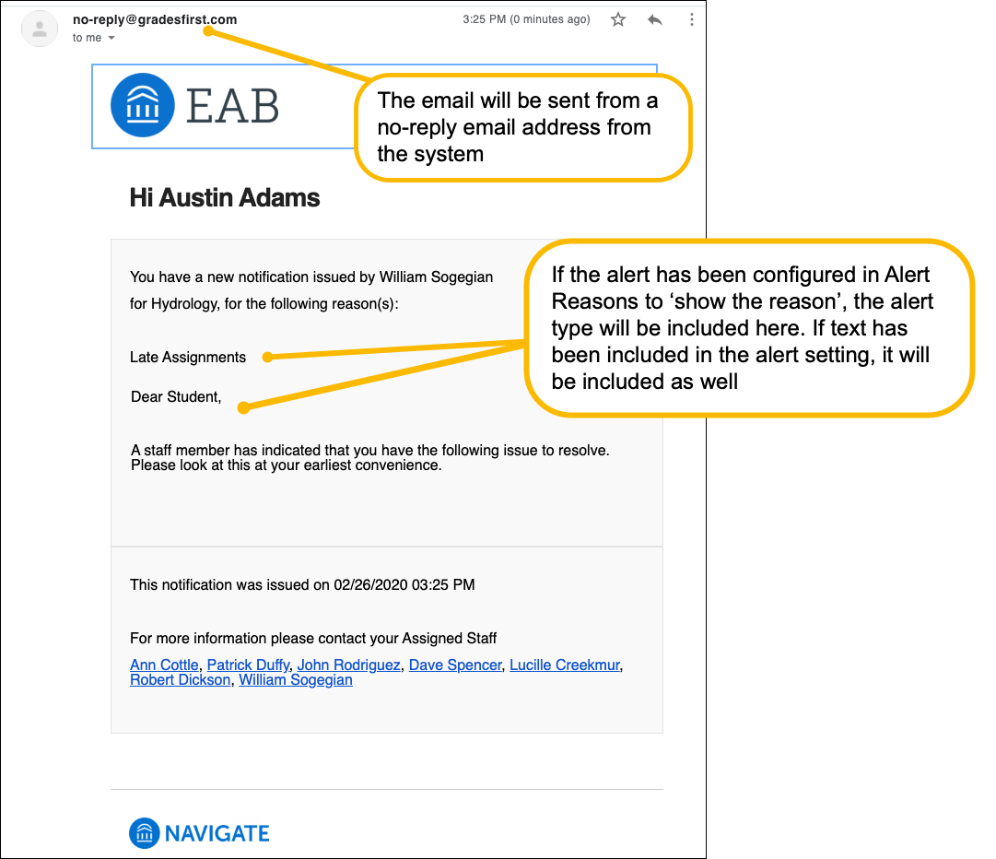
Assigned staff notification. If the Alert Reason is set up to notify staff, the student's assigned staff who are selected to receive that reason's notifications get an email letting them know about the Alert. You can reply to the student directly from this email, or from an email triggered by a Progress Report, by clicking their name.
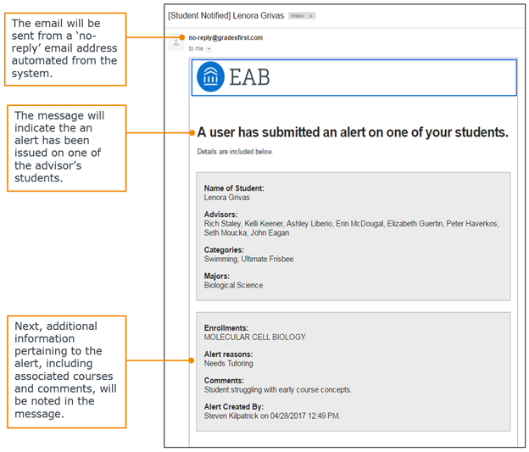
Viewing Alerts
Alerts show up in two main places: the Student Profile and Professor Home.
Important: You cannot view Alerts you issued from your own Staff Home page.

Student Profile. The total number of Alerts for a student appears at the top right of their profile. This count includes every Alert, Case, and Progress Report issued for the student. Depending on your institution's settings, it may include every Alert ever issued, or only the ones from the current term.
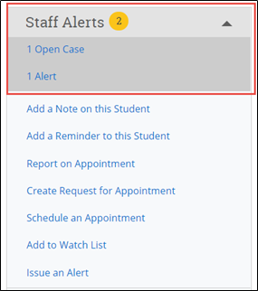
Important: Because the total count includes Alerts, Cases, and Progress Reports together, the same event can be counted more than once. For example, one Progress Report that issues an Alert, which then opens a Case, adds up to three even though all three actions came from the same Progress Report. Keep that in mind when you use the count to decide how to follow up.

To see the details behind the count, click the Alert count itself, or go to the History or Reports/Notes tab on the student's profile. Whether you have access to those tabs depends on your institution's settings.
The Staff-Initiated Alerts section on the Reports/Notes tab lists Alerts on their own:
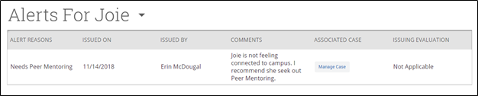
- Alert Reasons. Every reason tied to this Alert, based on your Care Unit and permissions.
- Issued On. The date the Alert was issued.
- Issued By. Who issued the Alert.
- Comments. Any comments entered when the Alert was issued.
- Comment Included in Email to Student. Whether the comments were sent to the student.
- Associated Case. A link to the case, if one opened automatically or was opened manually. You may or may not have permission to view or manage it.
- Issuing Evaluation. If the Alert came from a Progress Report, this shows details like the course, whether the student is at risk of failing, absences, current grade, and professor comments, depending on your permissions.
You can also see Alerts mixed in with everything else on the History feed. If you want to see Alerts on their own instead, select the dropdown at the top of the History feed and choose Alerts for the student's name.
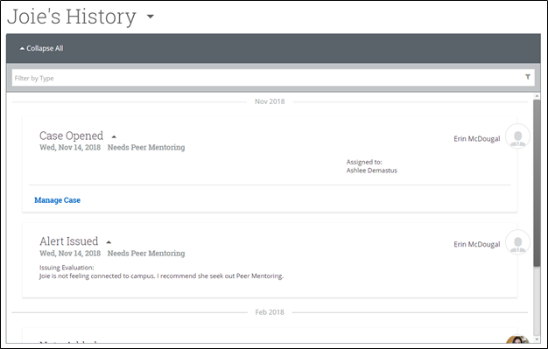
Professor Home. Faculty see the Alerts they have issued in the My Issued Alerts section, including links to any Progress Reports or Cases tied to them. Each row shows the date issued, the student's name, the reasons for the Alert, whether a case opened, and whether the Alert came from a Progress Report.
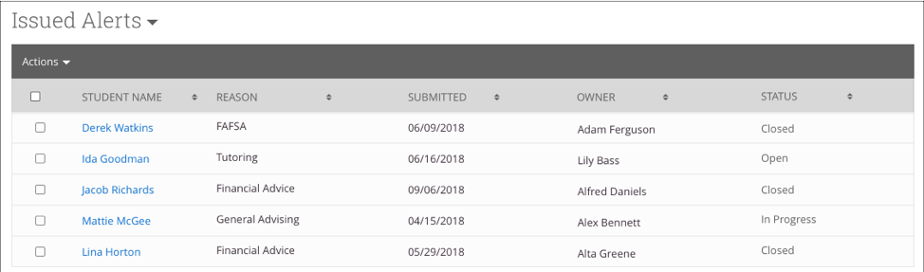
If a case has opened, faculty can click it to see which Alert Reasons opened the case, its status, and the outcome once it is closed. If the Alert is linked to a Progress Report, faculty can open that report from here too.
