NAVIGATE360 GUIDE
Messaging Campaigns in Navigate360
STAFF GUIDE

Purpose
This guide shows you what Messaging Campaigns are, how to open them, how to track how a campaign is doing, and the permissions you need. A Messaging Campaign lets you email or text a group of students to nudge them toward a specific action, such as finishing the FAFSA or scheduling an appointment.
What Messaging Campaigns Are
A Messaging Campaign lets you reach out to a specific group of students and encourage them to take an action. You build the group with Advanced Search, then send one or more messages, called nudges, by email or text. Campaigns work well for outreach such as enrollment reminders, financial aid steps, or inviting students to schedule an appointment.
Note: This guide is an overview of Messaging Campaigns and how to read their results. The full step by step for building and launching a campaign is a separate topic.

Opening Messaging Campaigns
You can open Messaging Campaigns two ways:
- From the Quick Links section on your Staff Home page.
- From the Campaigns page. Click the Campaigns icon on the blue navigation bar, then select Messaging Campaigns.
To start a new campaign, click Add New.
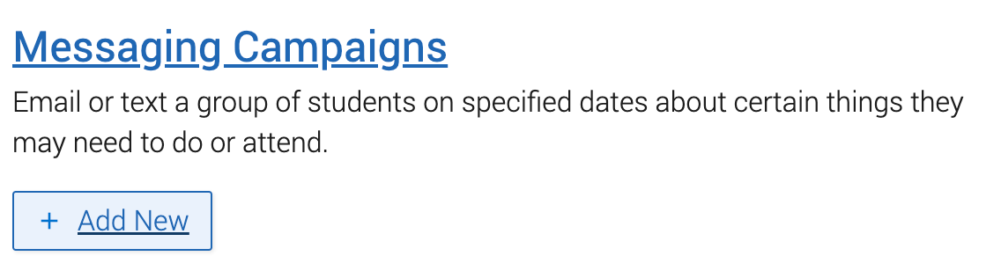
Tracking Your Campaigns
Once you have created a campaign, you track it from the Messaging Campaigns page. This page lists your campaigns with their status, number of students, most recent nudge, and next nudge. From here you can copy, resume, or delete a campaign, and clicking a campaign name opens its full report.
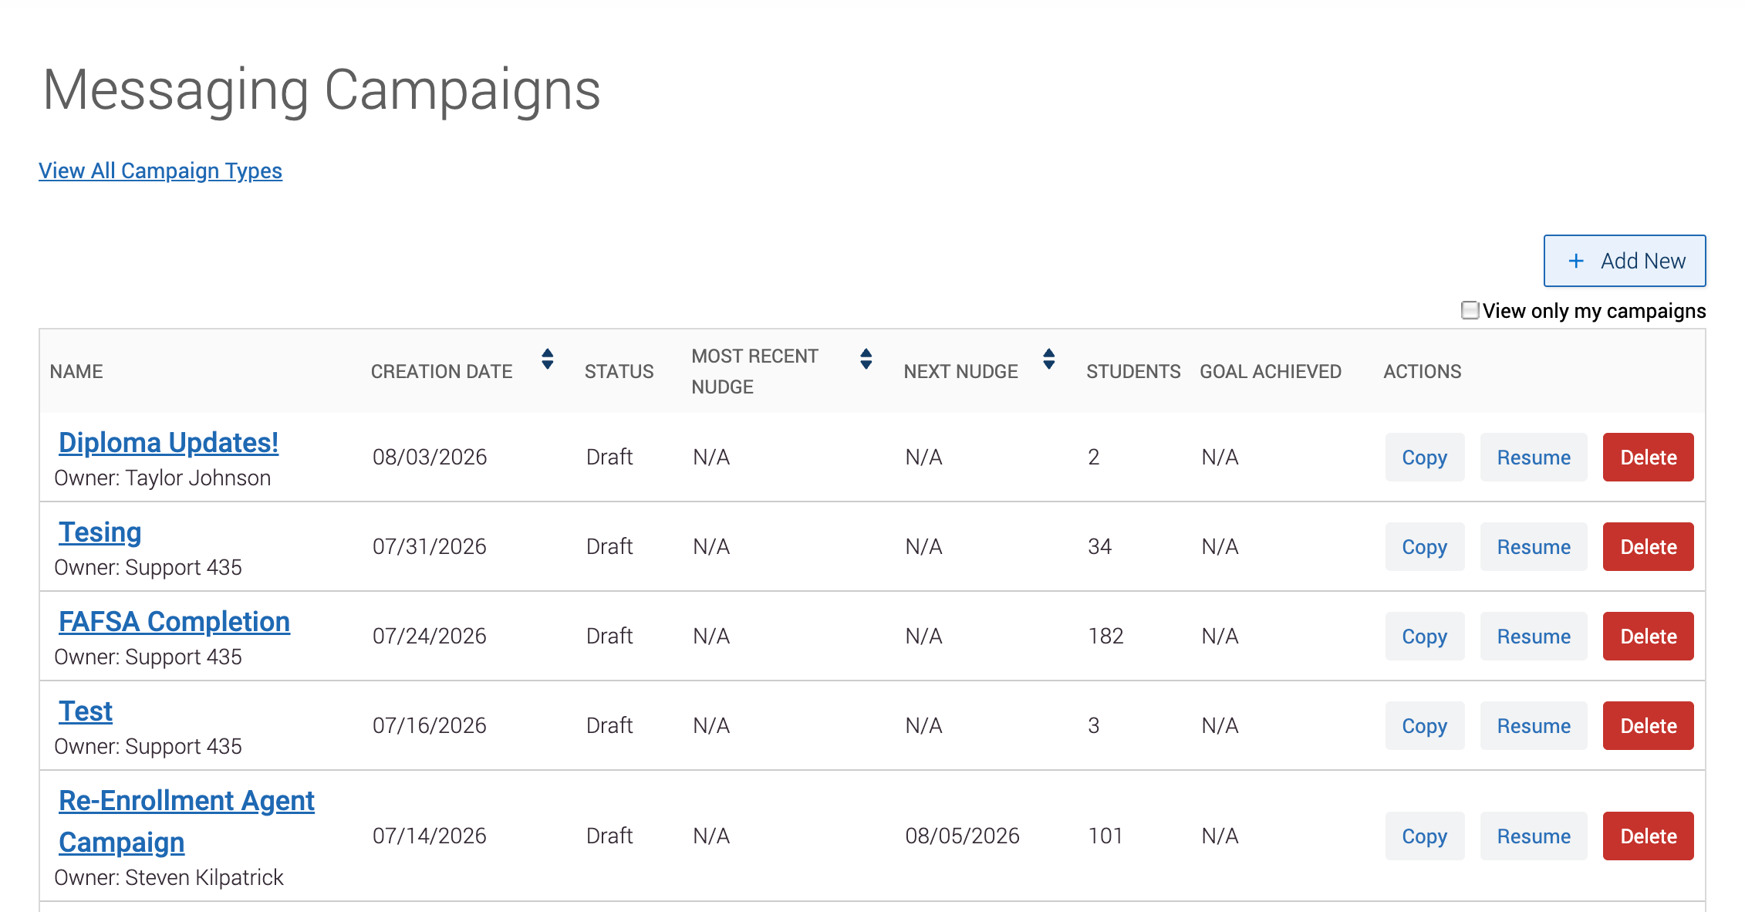
Note: Nudge metrics are not on by default. To turn them on, work with your care unit lead, who submits an IT ticket so the Navigate360 team can complete the work.

The Campaign Report and Its Metrics
Click a campaign name to open its report. The Options sidebar lets you edit campaign details, copy or delete the campaign, and export the student list.
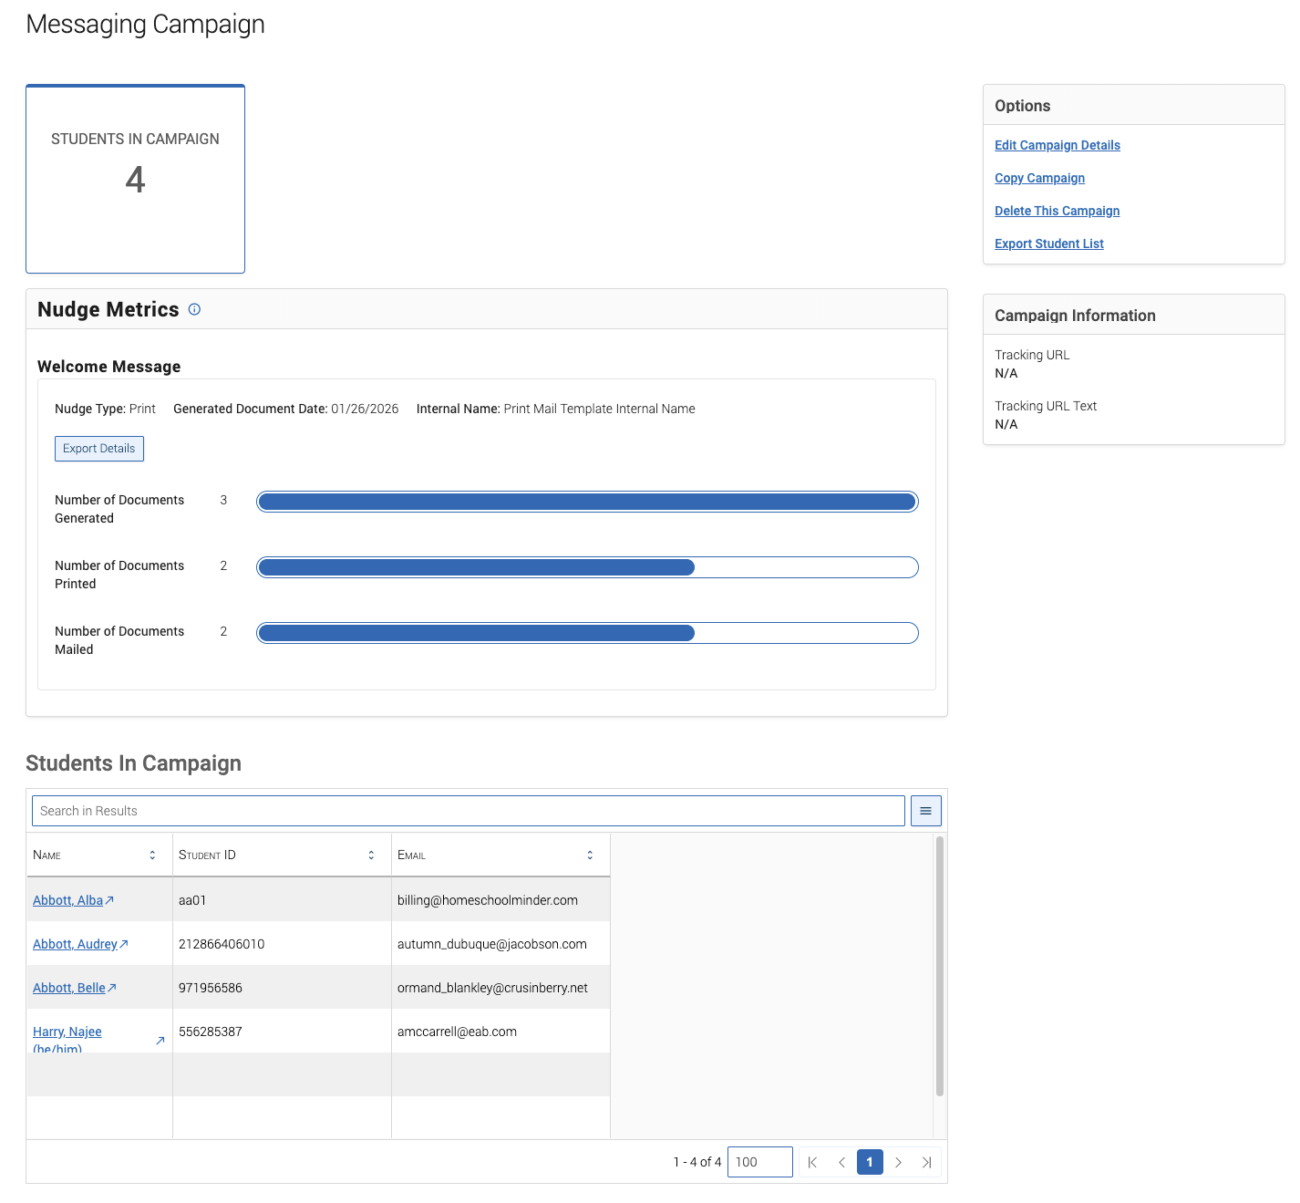
The report shows these metrics:
- Students in Campaign. The number of students who were sent the campaign message.
- Click to Open Rate. Compares unique clicks to unique opens. When it is enabled, you can pull student level detail with Export Details for email messages.
- Emails or SMS Sent. The number of messages sent. This can differ from the size of your original list.
- Emails Opened. The number of campaign emails that were opened. SMS opens are not tracked.
- Links Clicked. The number of times the link in the message was clicked. Email only.
The Students in Campaign table sits below the metrics. You can export it to CSV from the Options sidebar.
Campaigns with a Goal
If your campaign uses a Campaign Goal, the report adds two metrics:
- Goal Achieved. The percentage, and number, of students who met the goal.
- Goal Pending. The percentage, and number, who have not met it yet.
The goal, along with the report used to set it, appears in the Campaign Information box. You can see which students have met the goal and which have not on the Goal Achieved and Goal Pending tabs, and take action or export from there.
