NAVIGATE360 GUIDE
Messaging Students in Navigate360
STAFF GUIDE

Purpose
This guide shows you how to email and text students in Navigate360, where those messages actually go, how to see past conversations, and how to use Content Templates to send common messages faster.
What You Can Send
Navigate360 gives you two ways to reach a student directly: email and text. Communicating through the platform creates a record of the conversation that other staff or faculty with the right permissions can see. It is also a fast way to message more than one student at once. Access to emailing and texting depends on your user role permissions. If you do not see the option to message a student, or texting is not available to you, contact your Application Administrator.
Important: Navigate360 does not have a student facing message center. Emails you send through the platform go straight to the student's SPSCC email inbox, the same as any other email they receive. Texts go straight to the student's phone as a normal text message. Students are not logging into Navigate360 to read these messages.

Sending a Message
You can send an email or text to one or more students from Staff Home, Advanced Search, or a student profile. Most Actions menus across the platform include this option.
From a list of students. Select one or more students, then choose Send a Message to Student from the Actions menu.
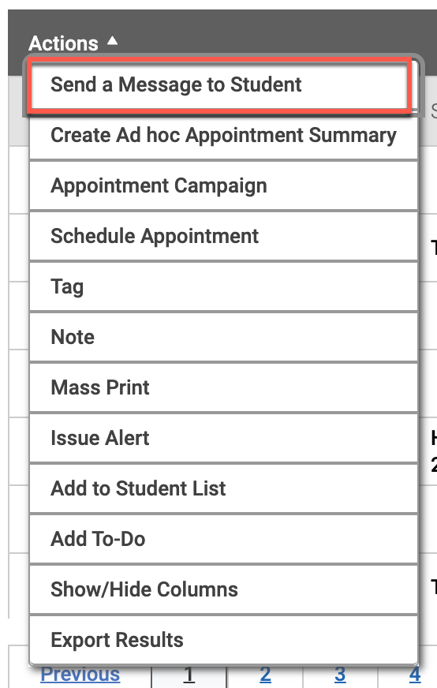
From a student profile. Select Message Student from the Options panel.
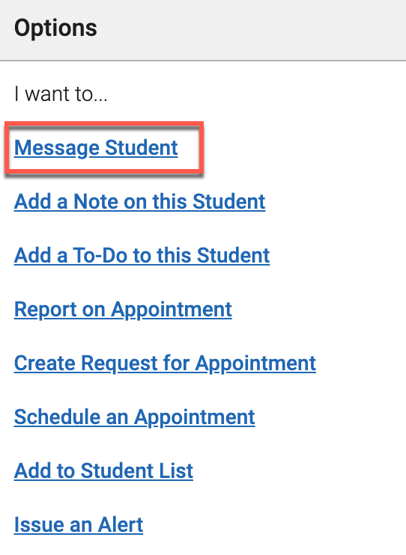
Either path opens the same Send a Message dialog, where you choose Email or Text at the top.
Composing an Email
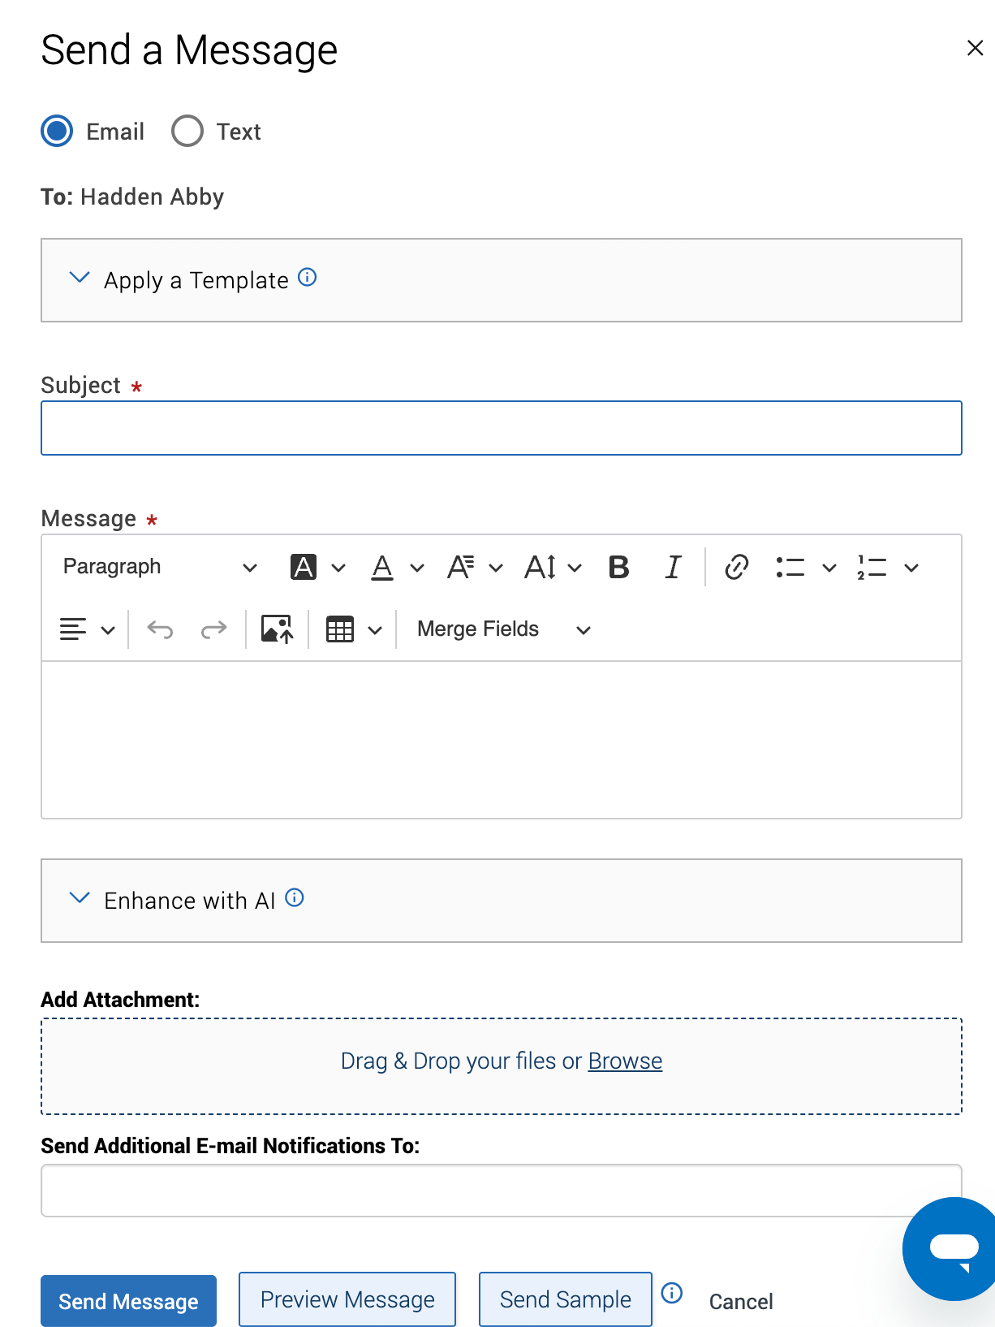
- Apply a Template. Start from a saved Content Template instead of writing from scratch. See Content Templates below.
- Subject. The subject line for your email.
- Message. The body of the email. There is no character limit. Any links need the full web address, such as https://www.spscc.edu rather than just spscc.edu. You can add images, tables, rich text formatting, and merge fields, and you can use Enhance with AI for help polishing the wording.
- Add Attachment. Drag and drop a file, or browse to upload one.
- Send Additional E-mail Notifications To. Add other students or staff you also want this email sent to.
If you have the Expanded Merge Tags permission, you can insert merge fields based on the columns of the V3 Students Report. If you do not have that permission, four merge fields are still available:
- {$recipient_name}. Inserts the recipient's first and last name.
- {$recipient_first_name}. Inserts the recipient's first name.
- {$recipient_last_name}. Inserts the recipient's last name.
- {$personal_availability_link}. Inserts your Personal Availability Link, or PAL.
Before you send, select Preview Message to see how the email will look on mobile, tablet, or desktop, or select Send Sample to send yourself a copy first.
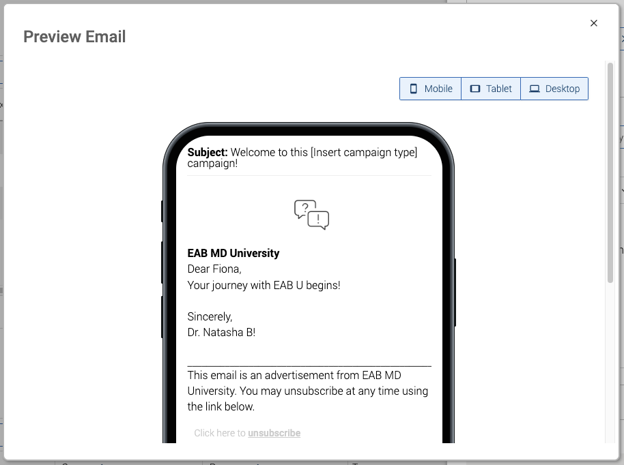
Composing a Text
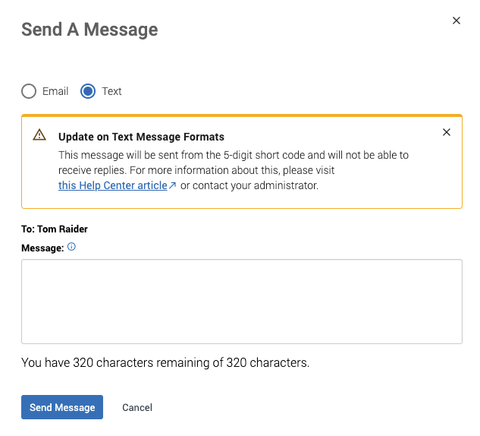
Texts only include a Message field and are limited to 300 characters from the standard GSM-7 character set. You can apply a Content Template here too, and use AI Auto Enhance or the AI Message Assistant for help with the wording.
Note: Some texts are sent from a 5 digit short code and cannot receive replies. When this applies, Navigate360 shows a banner in the Send a Message dialog letting you know before you send. Contact your Application Administrator if you have questions about which of your texts can receive replies.

Important: Sending an email or text to more than one student blind copies everyone on it. Each student sees the message as if it were sent to them alone. They do not know it also went to anyone else.

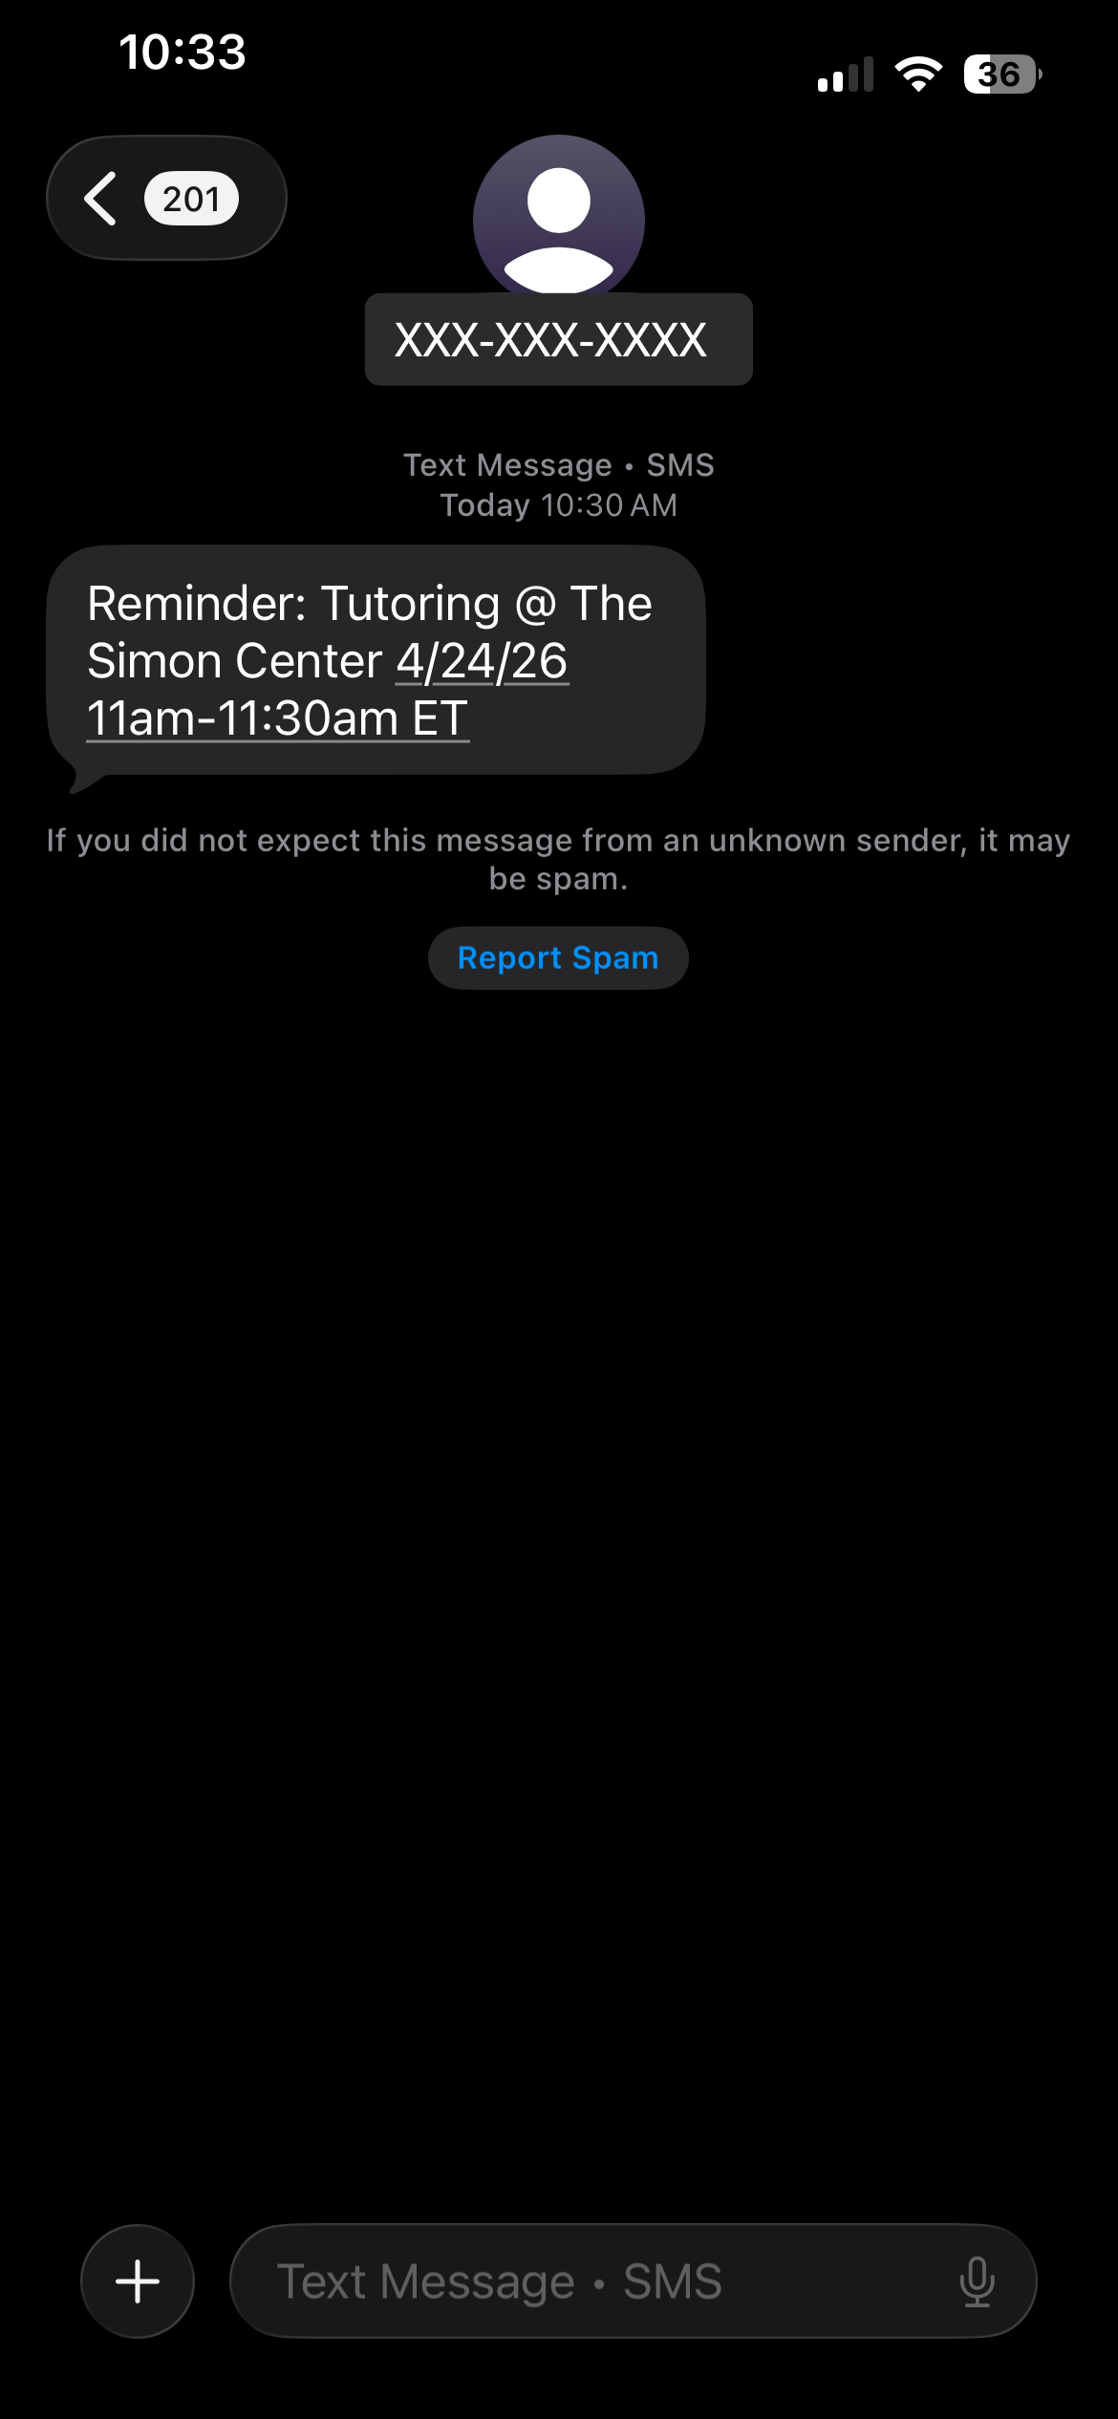 | This is an example of a text message a student might receive, sent from Navigate360.

If a student is able to reply, their response shows up in your Conversations, the same as a reply to any other text.
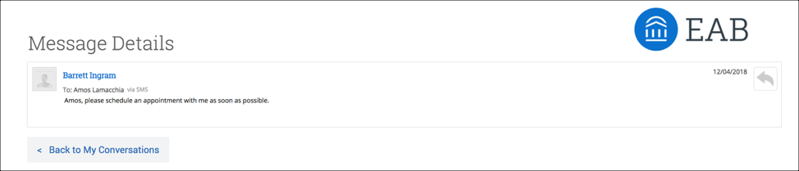
Automated texts from Navigate360. Some texts go out automatically rather than from a message you write. Appointment reminders, and some appointment and queue notifications, are sent this way and come from your institution's bulk messaging number once one is set up.
If a text goes out to more than 1000 students at once, it also comes from the bulk messaging number and cannot receive replies. A student who replies to that number gets a message explaining that replies to it are undeliverable. It helps to say this plainly in your original text, so students are not left waiting on a reply that will not come.
Viewing Conversations
Every email and text you send or receive through Navigate360 is tracked on the Conversations page. Open it from the envelope icon on the left sidebar.
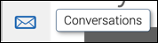
My Conversations is arranged like an email inbox, with the newest messages at the top.
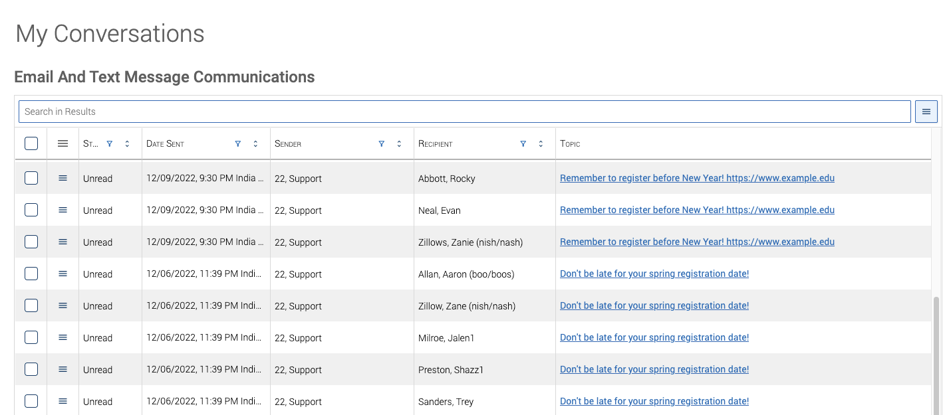
Many rows here are automatic, such as appointment reminders and campaign nudges, not messages you wrote yourself. To filter those out, use the filter on the Type column and search for Personal.
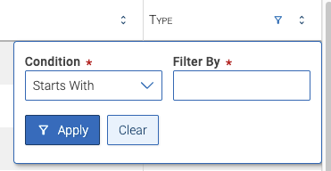
A few grid tools sit above the list and are worth knowing:
- Clear all sorts and filters. Clears every sort and filter so you see every message again.
- View grid table. Displays the grid results.
- View column manager. Lets you reorder or hide columns by dragging, clicking, or using the checkboxes. Changes reset to default when you leave the page.
- View sort manager. Lets you sort by more than one column at once. Using the column sort buttons directly resets this back to a single column sort.
- View grid settings. Lets you configure how the grid renders and exports data. Changes reset to default when you leave the page.
Selecting a message opens its details, whether it is a text or an email:
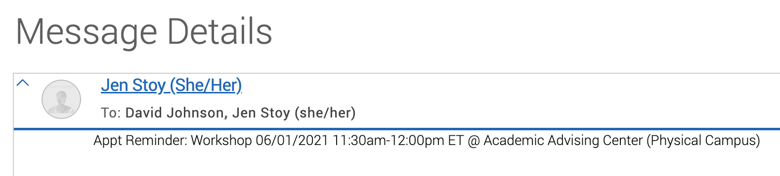
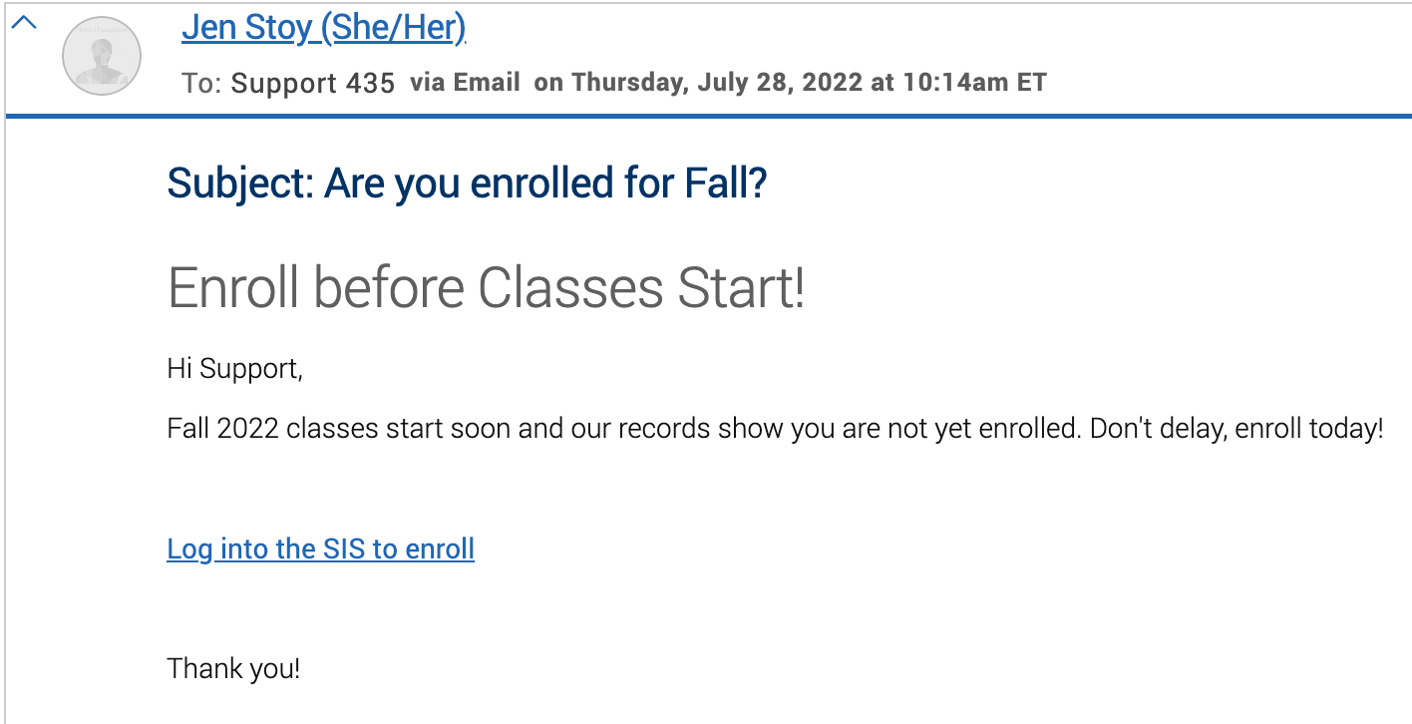
The unread indicator belongs to whoever received the message. It clears only when that person opens or marks the message as read from their own Conversations tab. Viewing a message from someone else's account does not clear it for them.
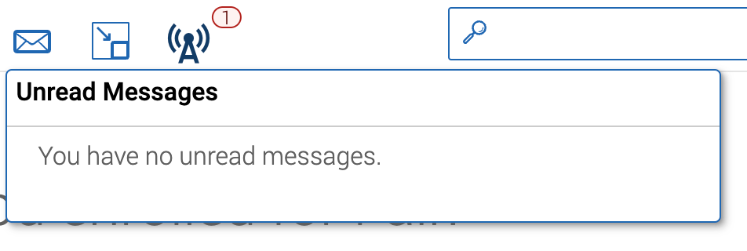
You can mark a message as read from the row itself, or select several messages and use the Mark As Read button above the grid.
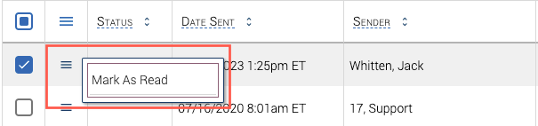
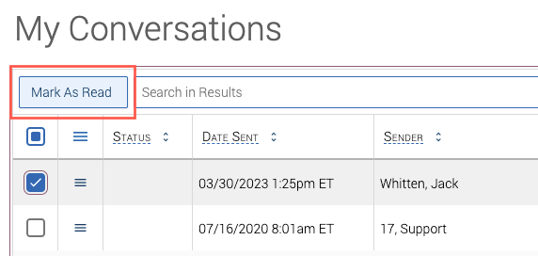
You can also see every message with a specific student on the Conversations tab of their student profile, without digging through your full inbox.
Content Templates
Content Templates let you build a library of reusable messages, such as appointment instructions, so you are not rewriting or copying and pasting the same message every time.
Accessing Content Templates. Select your account icon in the top right corner, then choose Content Templates.
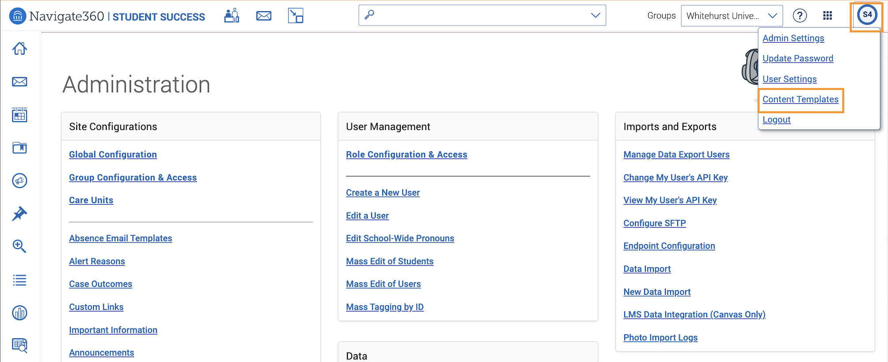
The Content Templates page has two tabs. My Templates holds anything you have created yourself. Public Templates holds anything shared with all Navigate360 users at your institution. Both tables are searchable.
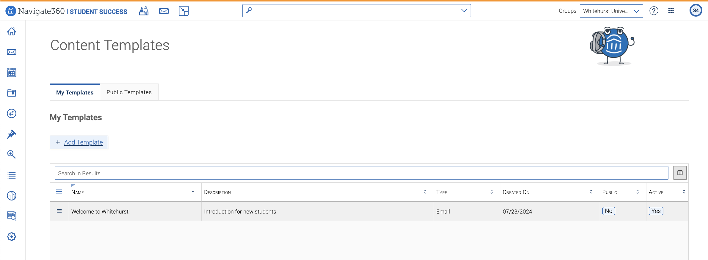
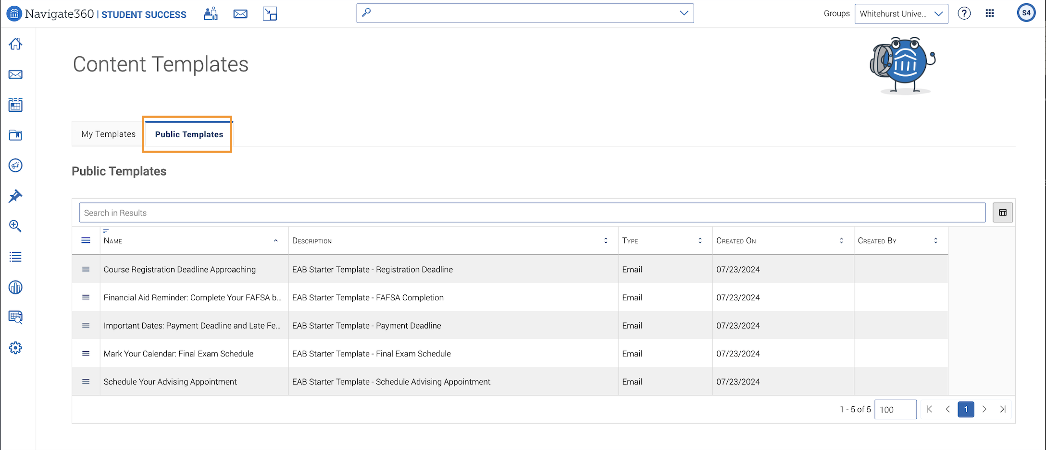
Creating a template. Select Add Template on the My Templates tab to open the Compose Template page.
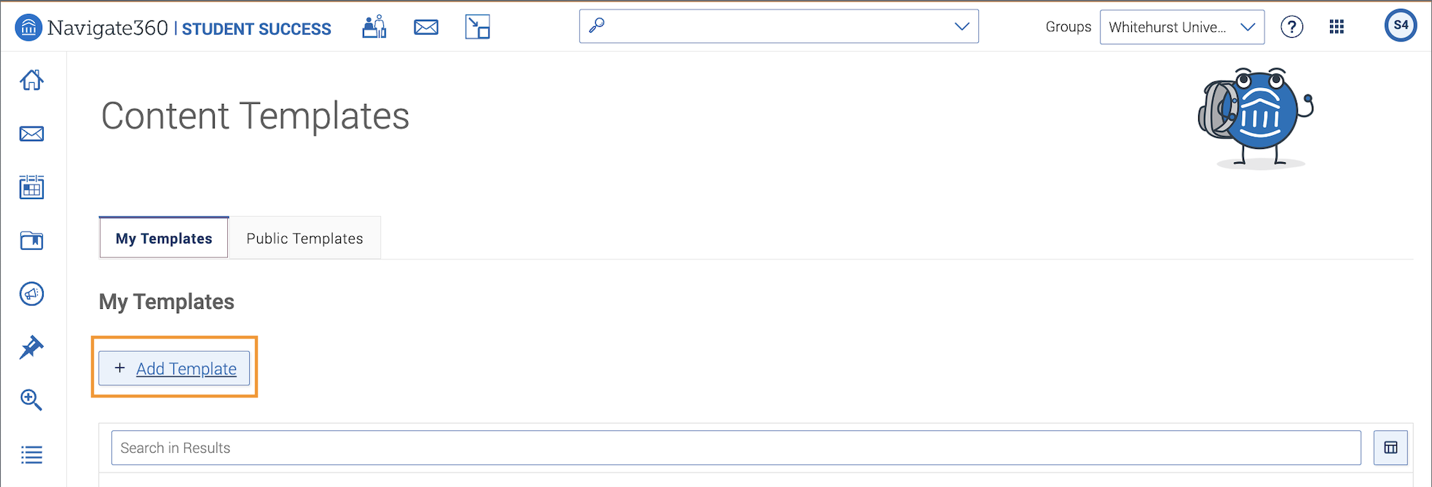
- Template Name (required). Keep it short and memorable, especially if it will be public.
- Template Is Active. Check this so the template shows up as an option when composing an email or text.
- Template Description. A brief note to help people find this template when searching.
- Make Template Public. Check this to let any user with the Use Templates permission apply it. Leave it unchecked to keep the template just for you.
- Template Type. Choose Email or Text. Text templates are limited to 300 characters in the GSM-7 character set.
- Branding Template. Pick a header and footer for the template from this menu.
- Subject. The email subject line. This only applies to email templates.
- Message or Description. The template content. Email templates support rich text, including links, images, lists, tables, and attachments. Text templates are limited to 300 plain text characters. If your institution has Message Content Creator features, those tools appear beneath this field for emails and texts.
A preview on the right shows how the message will look to recipients, in a mobile, tablet, or desktop frame.
Select Save Template when you are done. It then shows up in the table on My Templates.
Using content templates. Once you have access to at least one template, Apply a Template shows up when you are composing an email or text anywhere in Navigate360, grouped into My Templates and Public Templates. Loading a template overwrites any content you have already typed, along with the header and footer configured in that template.
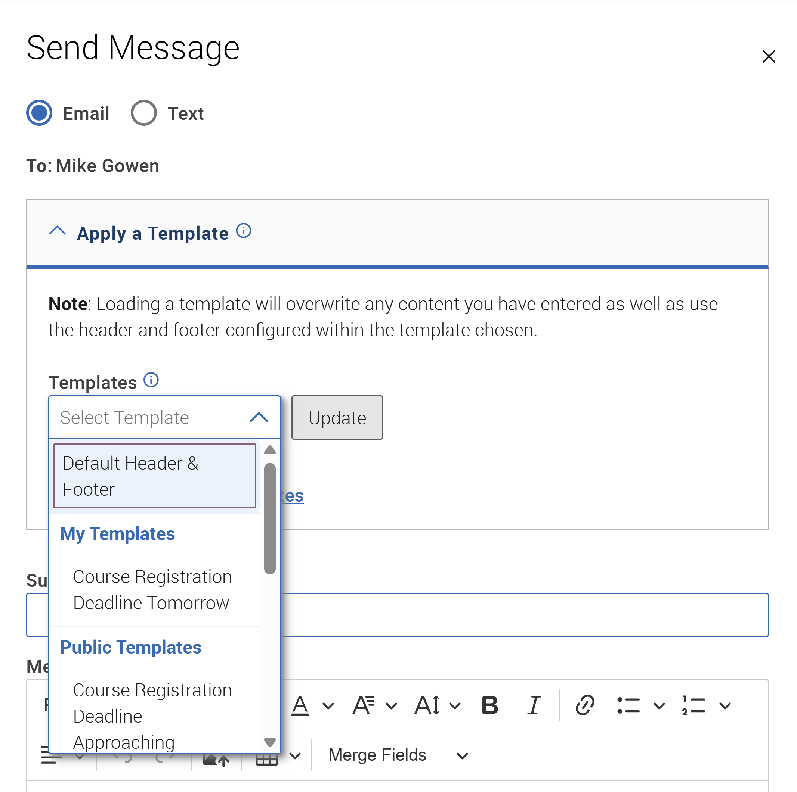
Besides the Send a Message dialog, content templates can also be applied to:
- Welcome messages, success messages, and nudges for Campaigns.
- Invitations, RSVP reminders, RSVP confirmations, and event reminders for Events.
- Email settings for Alert Reasons.
Merge tags in content templates. You can insert merge tags directly into Email templates while creating or editing them. When a template with merge tags is applied to a campaign or event message, the merge tags carry over and are filled in when the message sends. You can also insert merge tags directly into a message after applying a template, even if that message did not start from a template.
Templates built with the HTML editor also support merge tags. Selecting one of these switches the message editor into HTML mode and applies the template content, merge tags included, exactly as it was built.
Note: Merge tag support only applies to Email templates. Text (SMS) templates and texts do not support merge tags. The merge tags available also depend on where you are using the template. If a template includes a tag that is not supported there, Navigate360 lists the unsupported tags, highlights them in the preview, and blocks saving until you fix the content or choose a different template.

The Apply a Template option you see when composing an email or text pulls from this same library, whether the template is yours or a public one you have permission to use.
Note: You need the Use Templates permission to use public templates, and the Create, Edit, Delete Own Templates permission to build and manage your own.

