NAVIGATE360 GUIDE
Reports in Navigate360
STAFF GUIDE

Purpose
This guide gives a high level overview of Reports in Navigate360: what they are, how to build one, what you can do with the results, and how to save, schedule, or automate a report you use often.
For the full, detailed version of this topic, see Reports in Student Success in the EAB Help Center.
What Reports Are
Reports pull data and analytics tied to student success programs, everything from appointments and alerts to enrollment and surveys. Open them from the Reports icon on the left sidebar. Your institution needs access to Strategic Care reporting, and your role needs permission for each individual report you want to use. If a report you expect to see is missing, contact your Application Administrator.
Note: You may hear these called V3 Reports. As Navigate360 phases out its older reporting tools, staff are shifting to just calling them Reports.

Building a Report
Every report starts the same way: you set Data Filters to narrow the report down to the students or activity you care about, then run it.
- Data Filters. For each row, choose a field, a condition, and a value. Fields are specific to the report type, and conditions depend on the field's data type, such as a date range for a date field. Add as many filters as you need with +Add Filter.
- Filters Logic. Choose how your filters combine. Match All Filters (AND) narrows your results, Match Any Filters (OR) broadens them, and Advanced lets you mix AND and OR logic for more complex reports.
- AI Filter Assistant. Where available, describe the report you want in plain language and select Generate Filters. You can still adjust the filters afterward, or revise your prompt to regenerate them. This requires a NavAI partnership and the AI Filter Assistant permission on your role.
- Checkboxes. Most reports also include checkboxes, both unchecked by default, to further narrow your results. Include My Students Only shows only the students assigned to you, which is the quickest way to pull your caseload. Include Inactive Users brings in students who are not active in the current term. The checkboxes you see depend on the report, so an appointments report also offers options such as Include Cancelled Appointments and Include No Shows.
Two common needs map to this section. To focus a report on your caseload, check Include My Students Only. To report on a specific group instead, use Data Filters to narrow to that group, such as by major, classification, or a Student List where that filter is available.
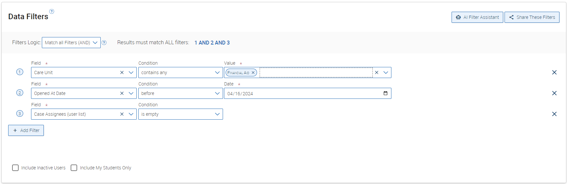
Select Run Report when you are ready. Reset Filters clears everything and lets you start over. If you want to hand a report off to someone else, Share These Filters copies a link that opens the report pre filled, as long as the other person also has permission to see it.
Note: A report with more than 50,000 rows will not display on screen. Export it to a CSV instead.

Working with Report Results
Once you run a report, results appear in a grid below your filters, with tools to search, reshape, export, and act on the data.
- Search in Results. Narrow the results further with a keyword search. Clicking a student's name opens their profile, the same as in older reports.
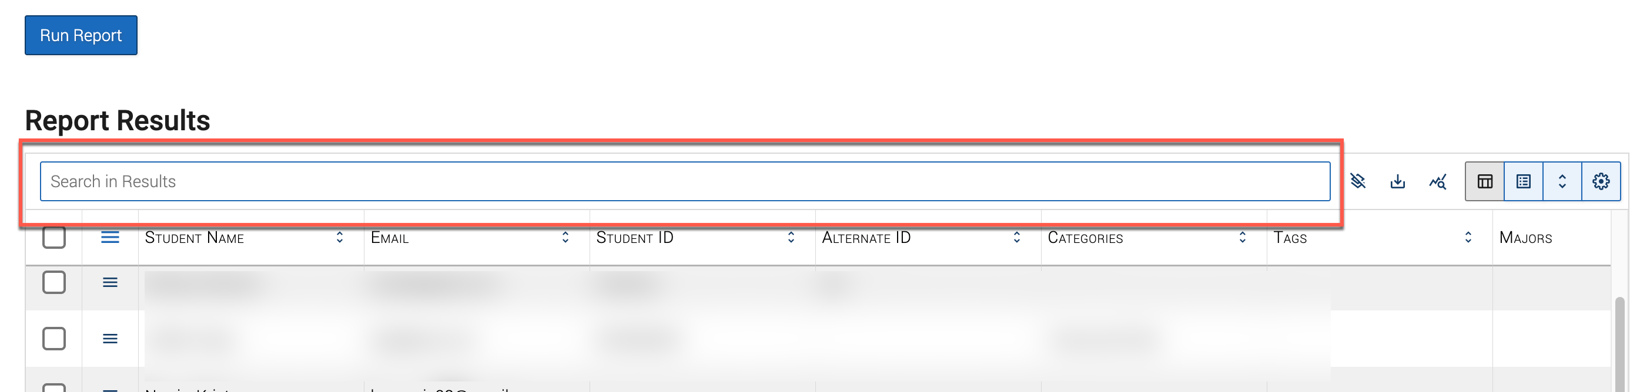
- The hamburger menu. Export the grid, load it as a pivot table, manage columns, adjust grid settings, or clear filters and sorts, all from this menu on the grid.
- Export. Every report can export to CSV, which opens in any version of Excel. Grid Settings let you customize the filename, quote character, and delimiter.
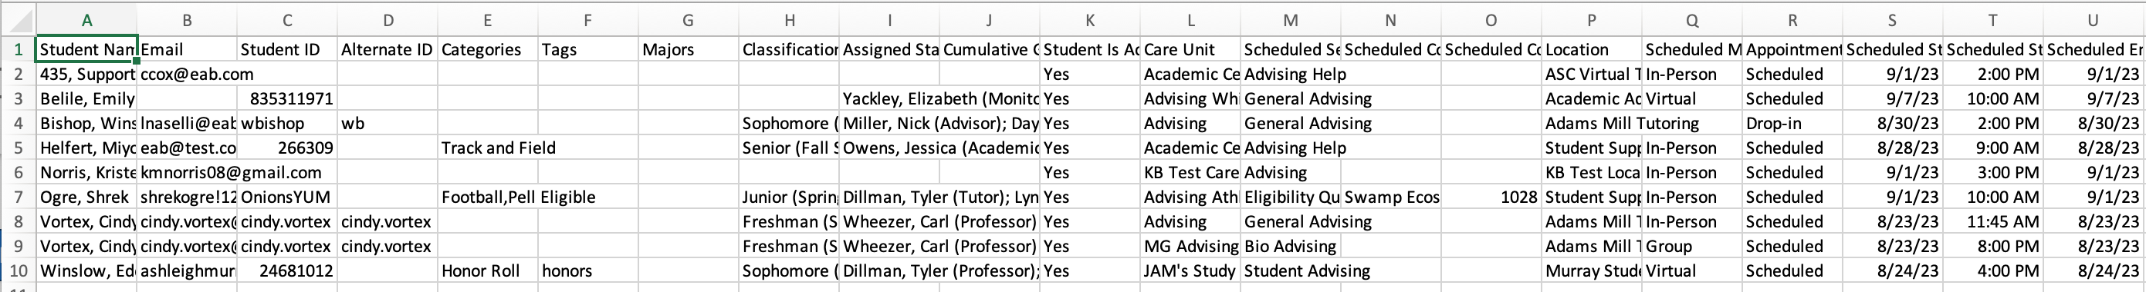
- Pivot tables and charts. Turn results into a pivot table or chart using the built in Flexmonster tool, useful for building tiles on the Staff Dashboard.
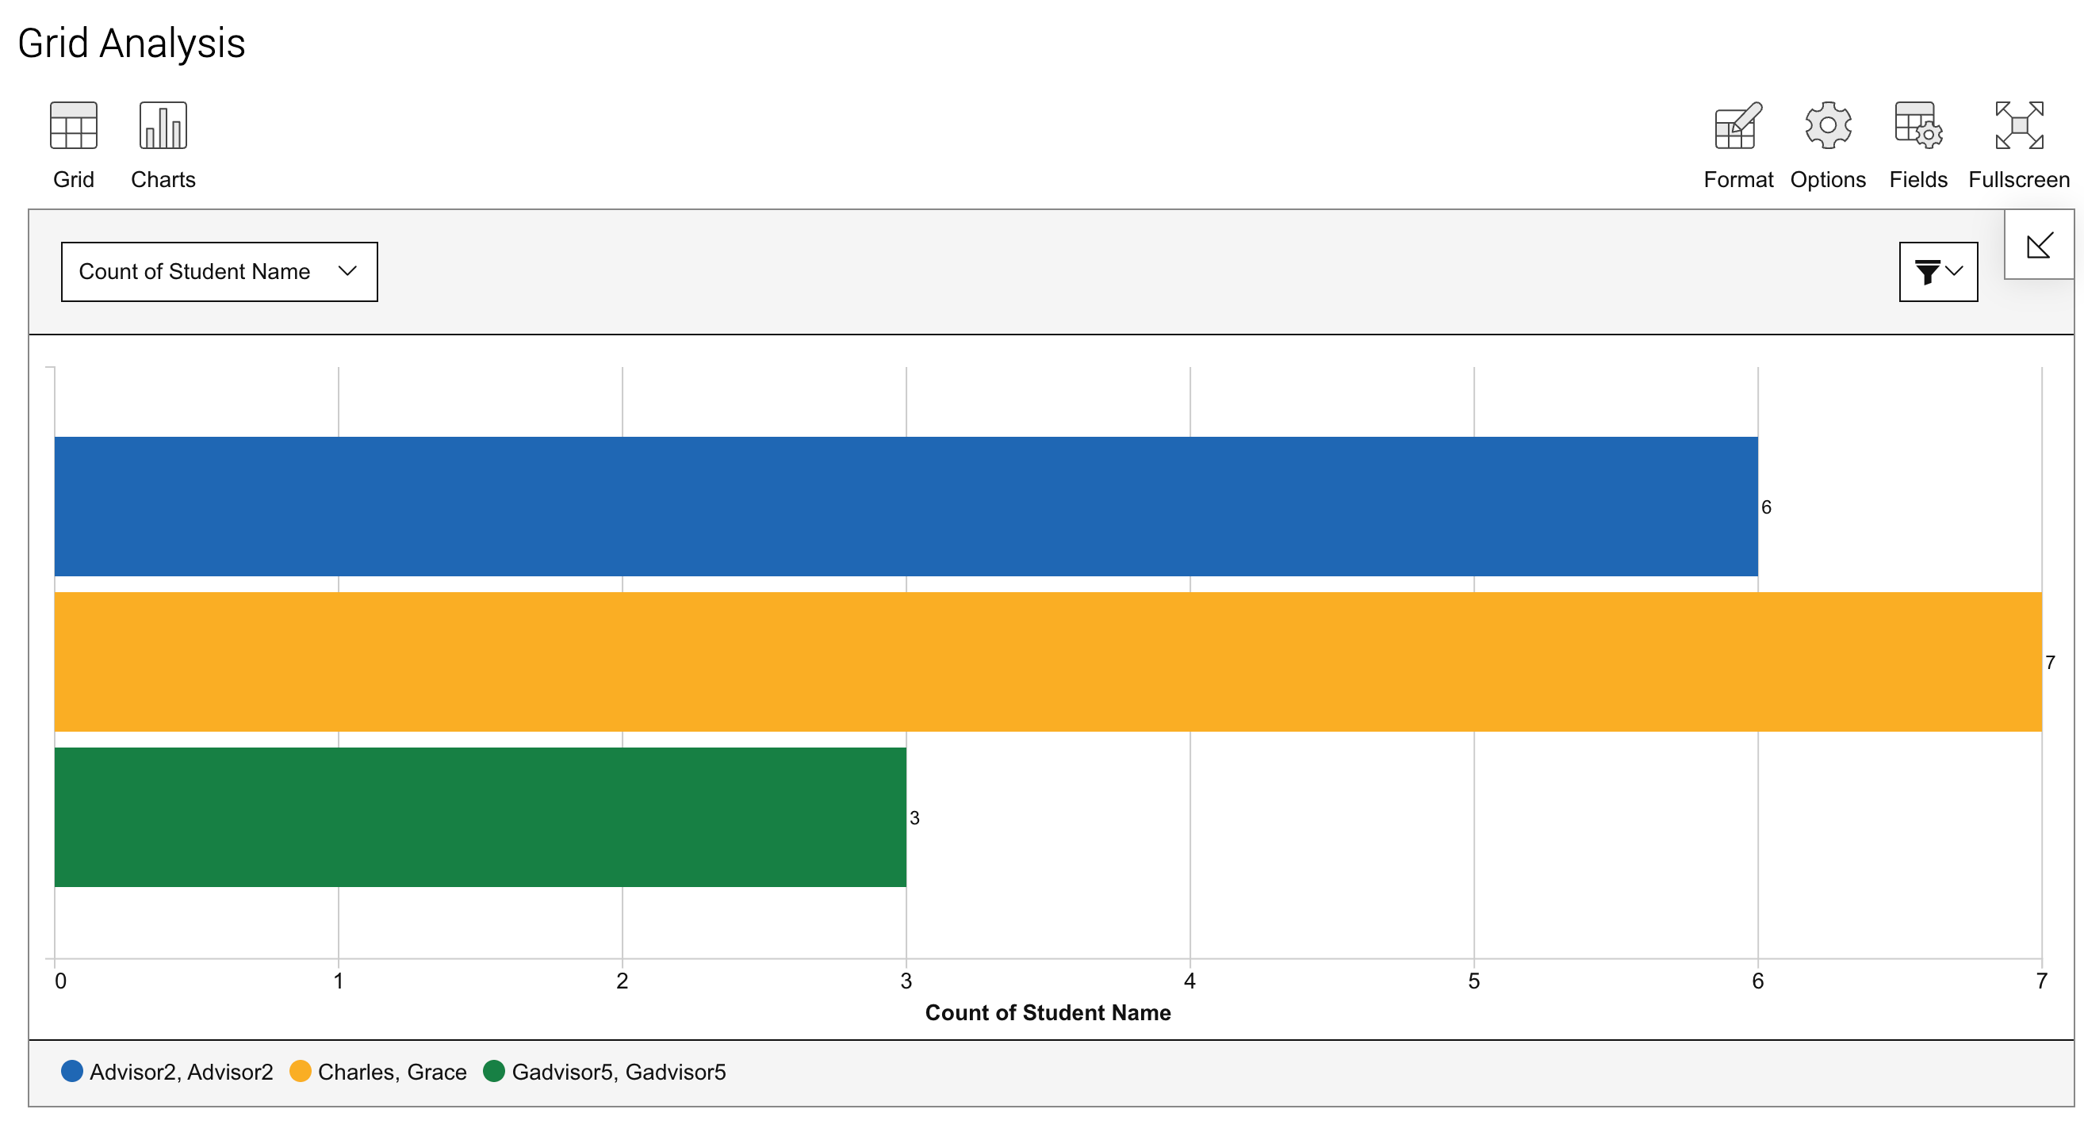
- Actions. Act on selected students right from the report, the same options available elsewhere in Navigate360: send a message, create an ad hoc appointment summary, create an appointment campaign, schedule an appointment, tag, note, issue an alert, add to a student list, or add a to do.
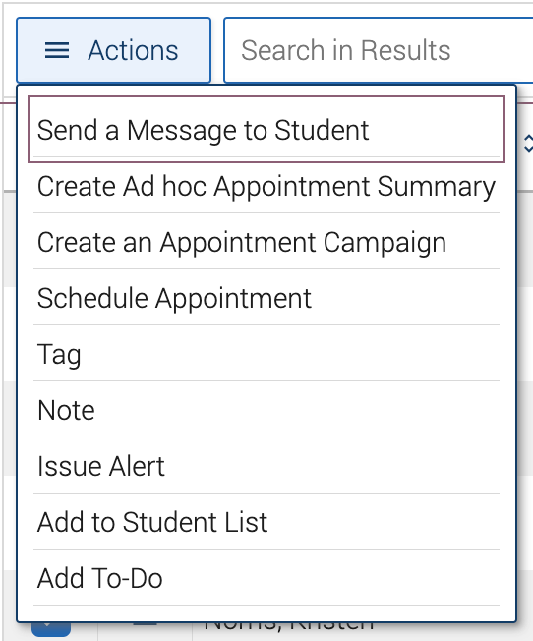
Note: Only the first 32,000 characters of a note show in the Notes Report or its CSV, a limit of Excel rather than Navigate360. Open the Student Profile to read a full note.

Saving, Scheduling, and Automating Reports
If you run the same report regularly, you do not have to rebuild it every time.
- Save a report. Run your report, then select Save As. It shows up afterward on the Saved Reports tab, ready to run again later with the same filters and most of the same grid settings.
- Schedule a report. From My Saved Reports or the Saved Reports table on Lists & Saved Items, set a schedule, frequency, and time, then save the rule. You get an email when the report is ready, with a link to open it.
- Automate a report. Build an Automated Action from a saved report to trigger follow up steps on its own. Automations you create appear on the My Report Automations tab, where you can edit or delete them.
Note: Downloaded reports stay available in the Download Center for 7 days.

