NAVIGATE360 GUIDE
Student Lists in Navigate360
STAFF GUIDE

Purpose
This guide shows you how to use Advanced Search to find groups of students and how to build Student Lists so you can work with the same group over time. You will learn what a Student List is, how it is different from a Saved Search, the ways to create one, where you can use it, and what you can do from the Actions menu.
What Is a Student List
A Student List is a fixed list of students, saved by their student ID. Once you build the list, the same students stay on it even as terms change, unless you edit the list yourself. You can use a Student List to track a group over time, send messages, or start an appointment or survey campaign straight from the list.
Key difference: A Student List is not the same as a Saved Search. A Saved Search stores a set of filters and returns whoever meets those filters at the moment you run it, so the results change over time. A Student List stays the same because it is tied to specific students, not to filters. For example, a saved search for freshmen will show a different group a year later, but a Student List of those same freshmen will not change on its own.

Creating a List
There are three ways to create a Student List or add students to one.
Note: Some tools show every Student List in their filters, so use a clear naming pattern that explains what the list is for, such as F24 Transfer 1st Gen. If you are not sure what pattern to use, check with your Application Administrator.

Option 1. Create Student List or add students through Advanced Search
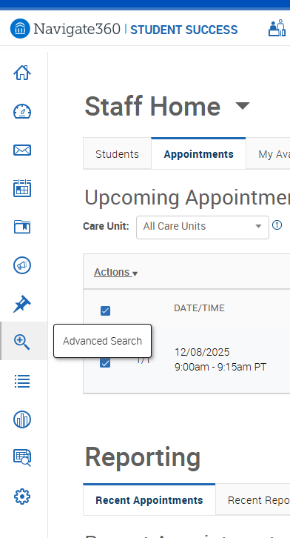  v | Start by running an advanced search to find the students you want:  - Click the magnifying glass icon on the left toolbar to open Advanced Search.  - Layer filters (like major, GPA, term) to find specific student groups.  - Use AND/OR logic to narrow or broaden your search. There are some filters that create OR statements. OR statements let you make multiple selections in a given field to increase the scope of your search. These search fields are indicated by the presence of an In Any of these identifier in the title.  - My Students Only limits the possible results to only your current assigned students. Advisor assignments can be direct, one-to-one assignments, or indirect major or category assignments. Tutors most commonly have direct, one-to-one student assignments. Students are assigned to professors based on their course rosters.  - Hit Search to see results.  - You can save your search for next time, super handy if you run it often!

When the list of student results appears, select all students you want to add to your Student List by checking the box in front of their name. You can select the entire list by clicking the All option. Note that if you decide to perform this action on only certain students from the list, you are limited to selecting from those students within the results page you are currently viewing, up to the maximum of 100.

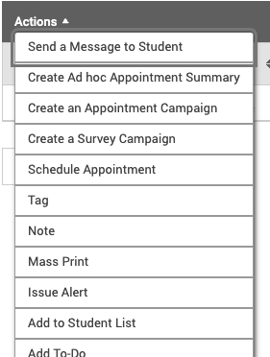 | After selecting your students, open the Actions menu. From here, follow these steps:  - Select Add to Student List.  - Add students to an existing list OR create a new list.  - After naming your list (if applicable), click Save. Note that student list names must be 32 characters or less.

You have a static list of students that will not change over time.
When adding multiple students to a list, platform notations will indicate if all, some, or none of the selected students are already part of a current student list.
If none of the students selected are on a student list, the student list check box will be empty.
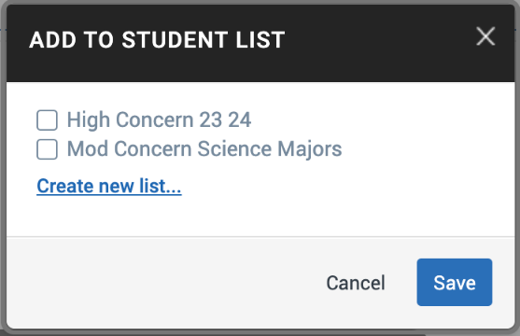
If some of the students selected are on a student list, the student list check box will have a dash "-" to indicate that some, but not all, of the students are already included on that list. If all of the students selected are on a student list, the student list check box will have a checkmark.
You can click on any of these checkboxes to clear these indications. This allows you to manage which list or lists you would like your selected students to remain on. Then, select the list as the placement for your selected student list.

Option 2. Upload Student List from a list of Student IDs
You can upload a list of students from a CSV file into Navigate360 to create Student Lists, too.
Warning! The file must be a CSV (comma delimited) file, not a CSV UTF-8 file.

To upload a student list from a CSV file, do the following steps:
- Open the Lists and Search page in Navigate360 Staff.
- Select Upload Student List from the Actions menu in the Student Lists section of the page as shown in the following image.
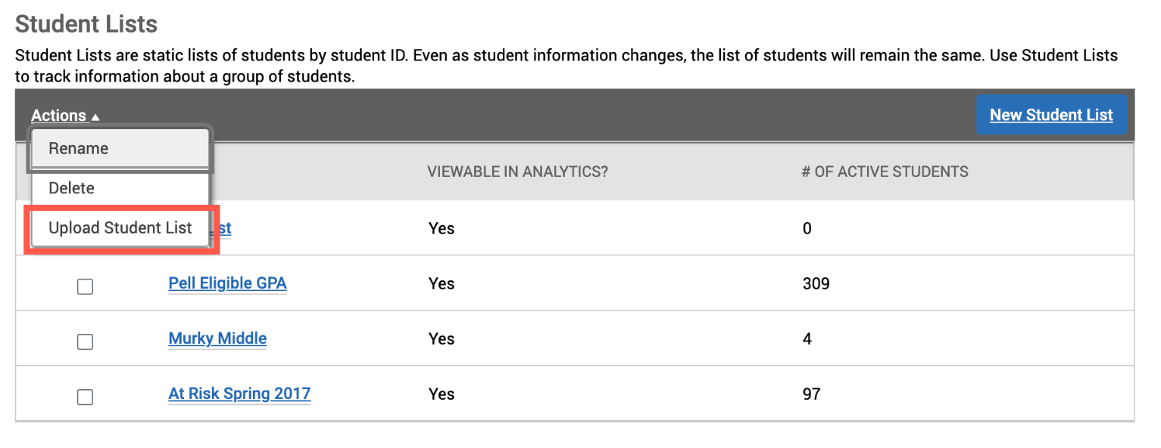
Upload Student List in Actions Menu
- Add students to an existing list OR create a new list.
- Select the CSV file and click Upload.
- Choose the column in your CSV file that represents Student ID (you can select either primary or alternate ID as of the upcoming STC 24.15 release) and then finish importing the file.
Warning! The column containing student IDs in the CSV must be wide enough to display the entire student ID or the platform cannot read it.

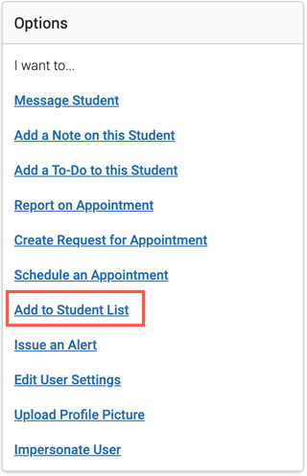 | Option 3. Add Students to Student List from Student Profile  Select Add to Student List in the Actions panel of a student profile as shown here.  Choose which Student List or Lists to add the student to, or create a new Student List and add the student to it.

Where You Can Use Student Lists
After you create a Student List, you can reach it and use it in several places in Navigate360:
- Staff Home. Click My All Assigned Students and pick a Student List or Saved Search to show on your Staff Home instead of your default assigned students.
- Lists and Searches page. Open, edit, delete, or save a new version of any list here. You can also upload new lists from this page.
- Advanced Search. Student List is a filter in the Student Information section, so you can narrow a search to students on one or more lists.
- Intervention Effectiveness. Pick a group with a Student List and track how their outcomes change over time, or compare them to another group.
Note: When you open a list on the Lists and Searches page, you can check Do not show this list in analytics dashboards. This hides the list from every analytics dashboard, including your own, which is helpful for sensitive lists such as students being referred to counseling. In most cases you do not need this box.

Note: Intervention Effectiveness updates overnight. After you create or change a Student List, allow about one day for it to show up there.

Using the Actions Menu
The Actions menu on a Student List lets you act on the students you select. To use it:
- Open a Student List from the Lists and Saved Items tab.
- Check the boxes next to the students you want to act on.
- Open the Actions menu and choose what you want to do.
Here is what each action does:
- Send a Message to Student. Send an email or text, with or without an attachment, to the students you selected.
- Create Ad Hoc Appointment Summary. Record an appointment with the selected students by creating an appointment summary report.
- Create an Appointment Campaign. Start an appointment campaign with the selected students already added.
- Create a Survey Campaign. Start a survey campaign with the selected students as recipients.
- Schedule Appointment. Open the Schedule Appointment page to book time with the students. If you pick more than one student, it starts as a group appointment.
- Tag. Add existing tags to the students profiles. You cannot create a new tag from here.
- Note. Add a note to the students profiles.
- Mass Print. Print Custom Student Reports and Student Calendars for the selected students.
- Issue Alert. Open the Issue Alert dialog to mark a student at risk. You can only do this for one student at a time.
- Add to Student List. Add the selected students to another list.
- Remove From Student List. Take the selected students off the current list.
- Add To-Do. Add staff to-dos for the selected students.
- Add Journey. Assign the selected students to a Journey. This only shows if your school has turned on Journeys.
- Export Results. Download a CSV of the students to use in other systems.

