NAVIGATE360 GUIDE
Student Profile Agent
STAFF GUIDE

Feature Overview
Student Profile Agent is an AI feature that staff can use to ask questions about their students. It can be used to prepare for appointments, synthesize key student information, or gain updates about a student. Student Profile Agent summarizes key data points about the student with data accessible in V3 reports. Staff chats with any activity in the last 30 days are maintained in Chat History. Staff can select New Chat at any time to start over with the chatbot.

Access Student Profile Agent by opening a Student Profile on any tab, and navigating to Options >> Open Student Profile Agent.
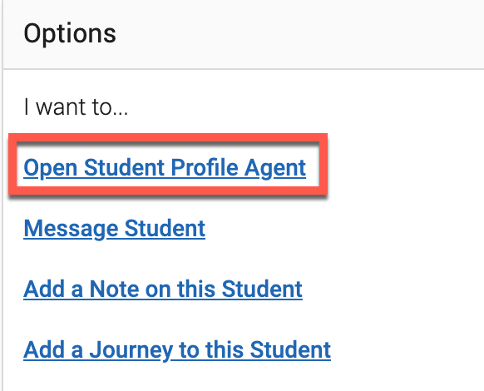

The Student Profile Agent opens.
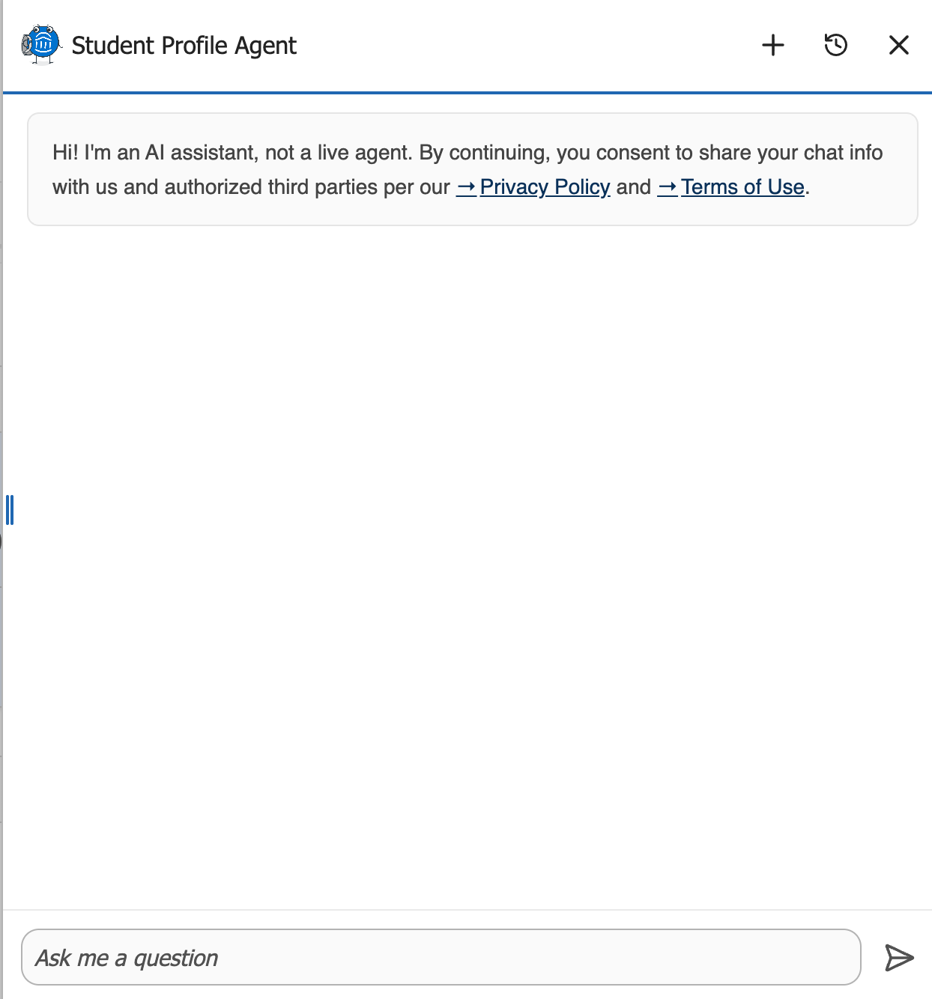
As with other Navigate360 AI features, the user then asks the Student Profile Agent a question. Some examples are listed below. Note that Student Profile Agent pulls data from data within V3 reports associated with that student, data in the Conversations tab of the student's profile, and Staff To-Do's, all from the last 12 months. The Student Profile Agent will only return answers with student data to which the user already has access through V3 reports. If you do not have access to the corresponding V3 report, the answer returned may not match the data in the Student Profile. Custom Attribute data is not currently accessible to the Student Profile Agent.

An example of a successful conversation about a student is displayed below.
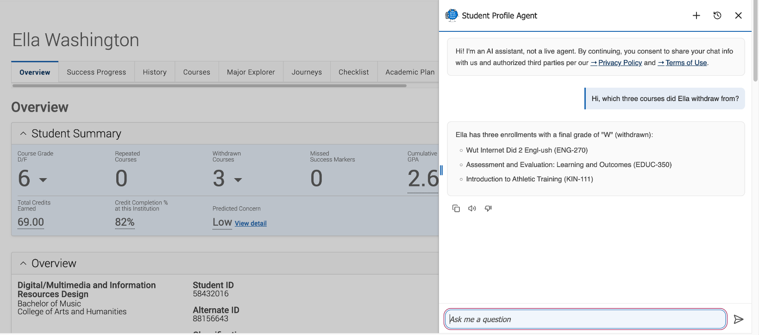
You may also add a To-Do about a student from Student Profile Agent. An example of this is shown below.
