NAVIGATE360 GUIDE
Survey Campaigns in Navigate360
STAFF GUIDE

Purpose
This guide shows you what Survey Campaigns are, how to open them, how to track them, and what the recipient statuses mean. A Survey Campaign sends a survey to a specific group of students to complete in Navigate360 Student.
What Survey Campaigns Are
A Survey Campaign sends a survey to a selected group of students, who complete it in Navigate360 Student. The survey itself is built and published ahead of time so that it is available as a campaign template for you to send. You build your student group with Advanced Search.
Note: The survey you send comes from a template that has to be built and published before you can use it. If you need a survey that does not exist yet, work with your care unit lead, who submits an IT ticket so the Navigate360 team can complete the work. It must be published and marked to use as a campaign template before it will appear as an option. This guide is an overview, and the step by step for launching a campaign is a separate topic.

Before you start: You need a published survey template to send, access to Advanced Search to build your student list, and your students need access to Navigate360 Student to take the survey. Survey Campaigns are only available to partners with the Student Engagement Hub.

Opening Survey Campaigns
To open Survey Campaigns, click the Campaigns icon on the navigation bar, then select Survey Campaigns. To start a new campaign, click Add New.
Tracking Your Campaigns
After you send a campaign, you track it from the Survey Campaigns page. Each campaign shows three at a glance details:
- Creation Date. The date the campaign was created.
- Status. Whether the campaign is Draft, Active, or Expired.
- Students. The number of students in the campaign.
You can also copy a campaign, resume a draft, or delete a campaign from this list.
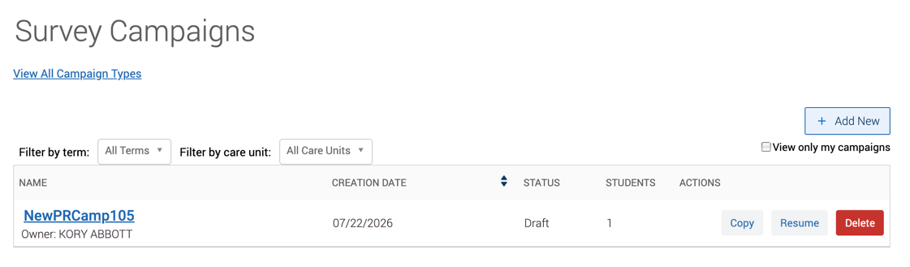
The Campaign Report
Click a campaign name for the full report. The Options sidebar lets you edit, copy, or delete the campaign, or export the student list. The report shows these metrics:
- Students in Campaign. The number of students who were sent the campaign.
- Surveys Completed. Number and percent who finished the survey.
- Surveys in Progress. Number and percent who started but have not finished.
- Surveys Not Started. Number and percent who have not started yet.
These values update once a day, starting at 7 am local time.
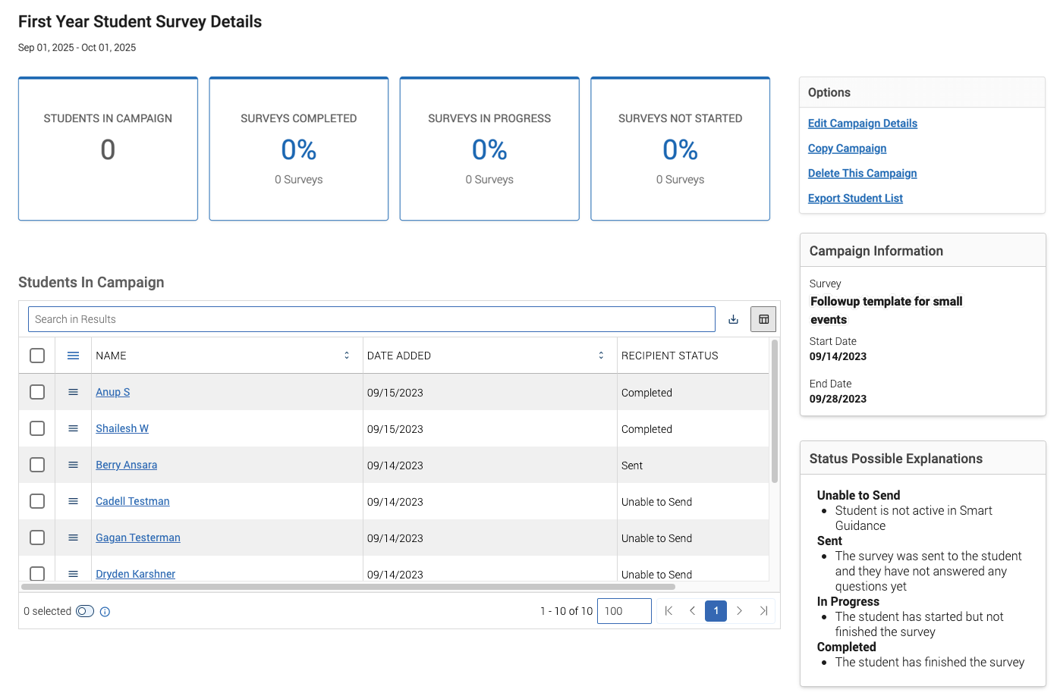
Recipient Status
The Students in Campaign table shows each student, the date they were added, and their Recipient Status. There are four statuses:
- Unable to Send. The student is not active in Navigate360 Student.
- Sent. The student got the survey but has not answered any questions.
- In Progress. The student has started but not finished.
- Completed. The student has finished the survey.
Important: Students must have access to Navigate360 Student, on desktop or mobile, to take a survey.

If a student shows Unable to Send, you can resend the survey. Check the box in front of the student name and click Resend Surveys. You can also use the menu next to a student to send a message or resend the survey.
