NAVIGATE360 GUIDE
User Account and Profile Setup in Navigate360
STAFF GUIDE

Purpose
This guide shows you how to sign in to Navigate360, set up your user settings, add an email signature and a personal bio, request a profile picture, and customize your dashboard.
Signing In
Go to login.spscc.edu and choose EAB Navigate360 from your list of apps. Navigate360 opens to your home page, which you can customize.
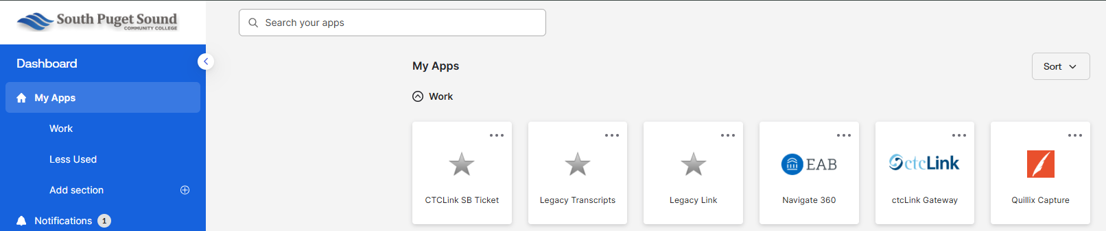
The Toolbar
In the upper right corner you will find a few helpful icons:
- The question mark takes you to the Help Center.
- The grid opens Kiosks.
- The person opens the Accessibility Adjustments menu.
- The circle with your initials opens a menu with User Settings, Content Templates, and Log Out.
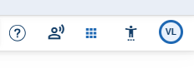
Accessibility Adjustments
The person icon opens options like text spacing, a dyslexic friendly font, content zoom, and a content timer, so you can set the display up to work for you.
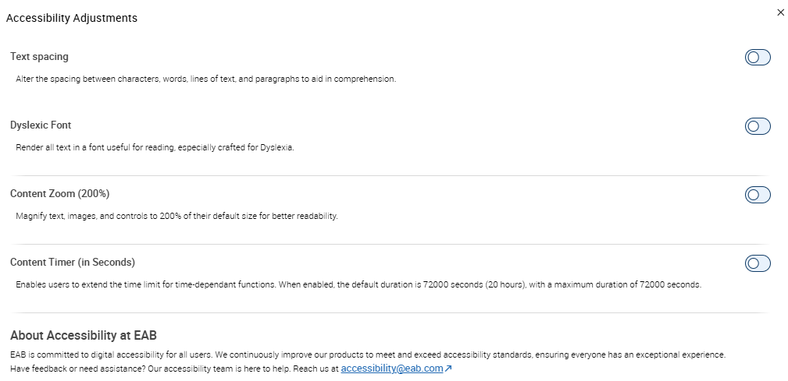
User Settings
Open the circle with your initials and choose User Settings. This is where you set your defaults and personalize your account:
- Default Term, Landing Page, Staff Home Tab, Student Profile Tab, and Care Unit. Set what you see first when you sign in.
- Time Zone. Set your local time zone so appointment times show correctly.
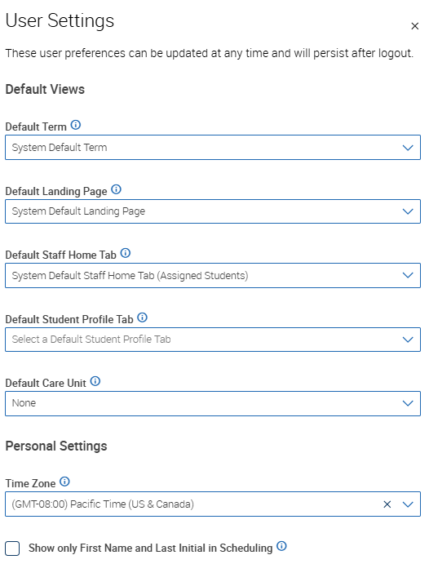
Email Signature and Personal Bio
Lower on the same page you can create an email signature and a personal bio.
- Email Signature. Create your own signature to apply to any email you send within Navigate360.
- Personal Bio. This is visible to students in the scheduler when they book an appointment with you.
Click Save when you are done.
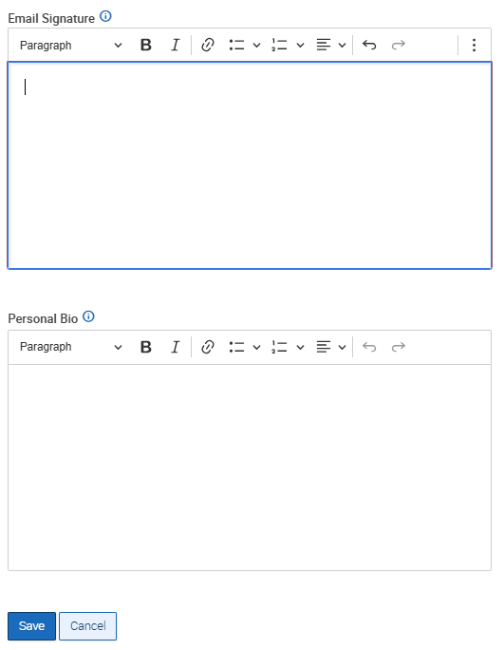
Your Profile Picture
To have your profile picture added, work with your care unit lead, who submits an IT ticket so the Navigate360 team can complete the work.
Customizing Your Dashboard
Your dashboard gives you a summary of your activity and your assigned students. It comes with default tiles, and you can arrange it to fit how you work.
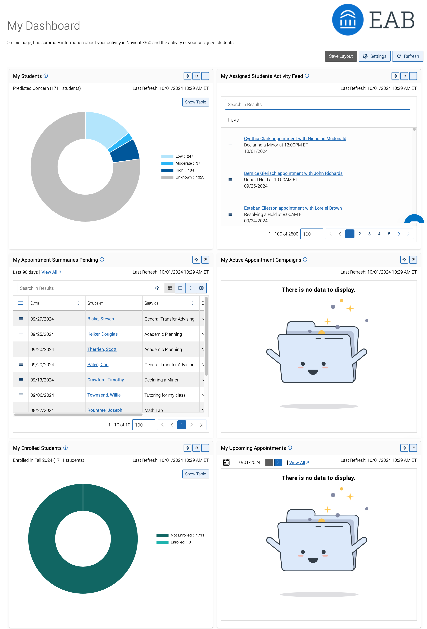
Save Your Layout
When you move or resize tiles, click Save Layout in the upper right to keep your arrangement.
Show, Hide, or Delete Tiles
Click Settings in the upper right to open Modify Tile Settings. Use the toggle next to a tile to show or hide it, or the trash icon to delete tiles you do not need.
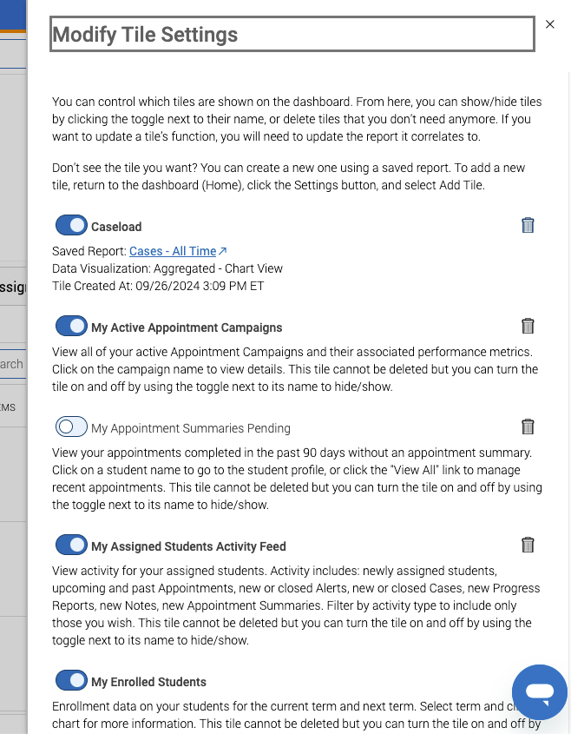
Add a Tile from a Saved Report
You can add your own tile built from a saved report. You must have a saved report first, so build and save one in the Reports area if you have not already. Then click Settings, choose Add Tile, give it a name, pick your saved report, choose how it displays, and click Save Tile.
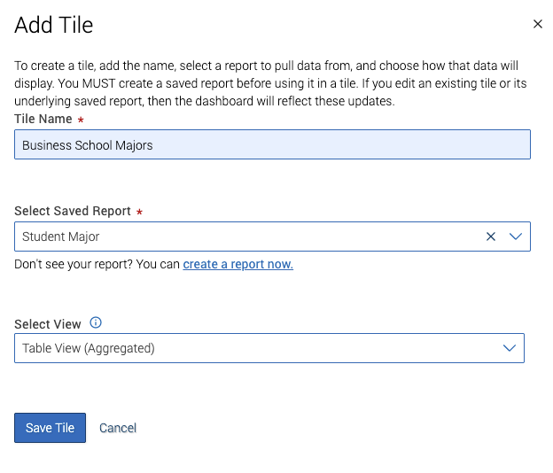
Your new tile then appears on the dashboard.
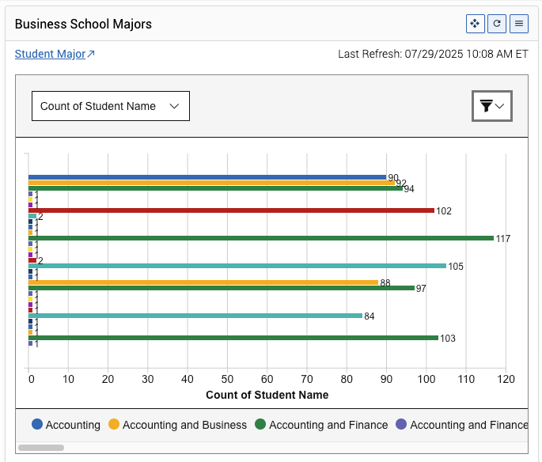
Default Tiles
Your dashboard starts with a set of tiles. The common ones are:
- My Students. A chart of your assigned students by predicted support level. You can switch the view or show a table.
- My Assigned Students Activity Feed. Recent activity for your students, such as new appointments, alerts, notes, and cases. You can filter by activity type.
- My Appointment Summaries Pending. Appointments from the last 90 days that still need a summary report.
- My Enrolled Students. How many of your students are enrolled for a term. You can change the term and switch between chart and table.
- My Upcoming Appointments. Your appointments for the day, with a link to view them all.
- My Active Appointment Campaigns. Your active appointment campaigns and their stats.

